

**COLLEGE OF COMPUTER AND INFORMATION SCIENCE**

**_____________________________________**

**Academic Year 2020-2021**

**ANALYSIS OF ELECTROENCEPHALOGRAPHY (EEG) DATASET ON SPECIFIED E-LEARNING AUDIO-VISUAL STIMULUS WITH ATTENTION PATTERN PREDICTION**

**VIA ENSEMBLE MACHINE LEARNING**

Cruzald Corong Boholst  
Carlo Andaya de Castro

Thesis Adviser: Prof. Dennis Aquino Martillano

Submitted to the Faculty of Malayan Colleges Laguna  
In Partial Fulfillment of the Requirements for the degree of

Bachelor of Science in Computer Science

The thesis attached hereto, entitled **“Analysis of Electroencephalography (EEG) Dataset on specified E-Learning Audio-Visual Stimulus with Attention Pattern Prediction via Ensemble Machine Learning”,** prepared and submitted by **Cruzald C. Boholst and Carlo A. De Castro** in partial fulfillment of the requirements for the degree of Bachelor of Science in Computer Science is hereby accepted.

|  |  |
| --- | --- |
| **ELLENITA R. RED, PHD**  Panel Chair | **JONALYN G. EBRON**  Panel Member |
| ______________________ | ______________________ |
| Date Signed | Date Signed |

|  |
| --- |
| **DENNIS A. MARTILLANO** |
| Adviser |
| ______________________ |
| Date Signed |

|  |
| --- |
| **JONALYN G. EBRON** |
| Program Chair, CS |
| ______________________ |
| Date Signed |
|  |

|  |
| --- |
| **KHRISTIAN G. KIKUCHI** |
| Dean, College of Computer and Information Science |
| ______________________ |
| Date Signed |

**Copyright**

“The author and the adviser authorize consultation and partial reproduction of this thesis for personal use. Any other reproduction or use is subject to copyright protection. Citation should clearly mention the reference of this work.”

Malayan Colleges Laguna, March 2022

**The Adviser the Authors:**

**Dennis Aquino Martillano Cruzald C. Boholst**



**Carlo A. de Castro**

**Biographical Sketch**

CARLO ANDAYA DE CASTRO is a Bachelor of Science in Computer Science student currently studying at Malayan Colleges Laguna. He has a specialization in Software Engineering and was a shifter from the Bachelor of Science in Computer Engineering Program of MITL. He once participated in the ASEAN Data Science Contest but unfortunately their study is not chosen. He then pursued playing Valorant which is an E-sports title, he and his teammates were back-to-back champions in the Malayan Esports League (2021-2022).

CRUZALD CORONG BOHOLST is a Bachelor of Science in Computer Science Student currently studying at the Malayan Colleges Laguna. He has a specialization in Software Engineering and was a shifter from Bachelor of Science in Computer Engineering program of MITL. He was also fond of E-sports and was a champion of the MESL DOTA 2 League. His hobbies are playing video games and playing the piano.

Abstract

The ushering of modern technology has become focal point of where development of new findings about neural activity can be monitored and analyzed as to where its activity is at its most. This study incorporated data and results to how students respond with perceived academic stimulus. With the question "How to analyze brainwaves data from an Electroencephalography (EEG) dataset to be used in determining attention patterns in an online-exhibited Audio-Visual Stimulus?" the researchers have garnered results by using machine-learning methods and various algorithms to be interpreted into interesting patterns. The findings in this study also identified the need for applicable AV materials which matches the interest of receivers like students which can be further utilized to conduct assessments in using Electroencephalography (EEG) data in analyzing different patterns not only in educational setups but also in other areas residing in this study.

# **Definition of Terms**

**Electroencephalogram (EEG)** - a test or record of brain activity produced by electroencephalography. It tracks and records brain wave patterns. Small metal discs with thin wires (electrodes) are placed on the scalp, and then send signals to a computer to record the results. Normal electrical activity in the brain makes a recognizable pattern. Through an EEG, doctors can look for abnormal patterns that indicate and other problems.

**Autoregressive model (AR) or Predictive Model** - predicts future behavior based on past behavior. It is used for forecasting when there is some correlation between values in a time series and the values that precede and succeed them.

**Data Preprocessing** - a process of transforming raw data into an understandable or usable format of which data cleaning, data integration, data reduction, and data transformation are done, mainly to check for data quality.

**Clustering -** a task of grouping a set of objects in such a way that objects in the same group (called a cluster) are more similar to each other than those in other groups (or clusters)**.**

**K-means Clustering** - one of the simplest and popular unsupervised machine learning algorithms. It is a method of vector quantization, originally from signal processing, that aims to partition n observations into k clusters in which observation belongs to a cluster with the nearest mean, serving as a prototype of the cluster.

**Ensemble Machine Learning** - is a technique that combines several base models in order to produce one optimal predictive model.

**Adaboost** - one of the first boosting algorithms to be adapted in solving practices. It helps to combine multiple weak classifiers into a strong single classifier.

**Sustained Attention** - the ability to focus on an activity or stimulus over a long period of time. It is what makes it possible to concentrate on an activity for as long as it takes to finish, even if there are other distracting stimuli present.

**E-Learning** - is learning utilizing electronic technologies to access educational curriculum outside of a traditional classroom. This can also refer to courses that are specifically delivered via the internet to somewhere other than video tape or over a television channel.

**Pattern Analysis** - an approach to neuropsychological test interpretation in which relationships among test scores are used to inform differential diagnosis. It is also the phase of pattern recognition that consists of using whatever is known about the problem at hand to guide the gathering of data about the pattern and pattern classes, and then applying techniques of data analysis to help uncover the structure present in the data.

# **Introduction**

In this age of technology, education has been elevated from usually occurring in the traditional classroom to online classes, like Massive open online courses (MOOCs). However, the use of audiovisual tools to help with learning has always been a constant in both the physical classroom and in E-Learning. These tools can range from the voice of the professor in a classroom along with words written on a blackboard, to a lecturer in a video with images that show a particular subject. Rasul et al. (2011) found that the use of audiovisual tools made the teaching and learning process effective due to how audiovisual tools can provide knowledge in depth and detail.

According to James G. Clawson (2008), audiovisual tools help people with different learning modes grasp and retain content of the class. This is because the visual aids can speak a thousand words to the visual learner, while the audial aids help for the word-oriented student. There have been many studies stating that the use of audiovisual tools in education stimulates interest according to human observations of human behavior (Ashaver & Igyuve, 2013), as well as studies that analyzed the situational interest of students during learning (Babiker et al., 2019). However, observations during this education process can be purely subjective (Liu et al., 2013).

During any audiovisual education process, neurons in the human brain are continuously active, emitting small amounts of electromagnetic waves. These electromagnetic waves are electroencephalography (EEG) signals. EEG signals are generally uncontrollable without training (Noachtar et al., 1999), which made it be considered viable to determine attention in many studies, such as in Multimedia Mobile Learning (Ni et al., 2020), attention feedback to improve focus in E-Learning (Sethi et al., 2018), determine confusion (Wang et al., 2011) as well as stress and confidence (Crowley et al., 2010). The authors Alwedaei et al. (2018) also used EEG-based analysis for learning through a virtual reality environment.

Most of these studies dealing with audiovisual stimulus use only the four major waves such as alpha (α), beta (β), theta (θ), and delta (δ) were obtained then trivialized the demographic of their participants, something of which can be a factor to analysis of EEG-based research. These trivialized features are ethnicity, gender (Cabrera & Loyo, 1993), age as well as gamma (γ) waves which, according to recent studies, can be related to selective attention (Viswanathan et al., 2019). In connection to stimulus brought about by audio visual tools, every learning process aligns attention as a crucial variable to the retention and the absorption of knowledge. However, paying attention requires an exertion of the learner’s energy, as well as the motivation to learn during the learning process. This motivation can also be aroused by educators, using various tools at their disposal such as audiovisual stimulus (Wilson, 2013).

The use of Electroencephalography (EEG) has now become a staple of many studies to understand how people perceive audio visual tools. Currently, the use of EEG dataset is gaining attention to help in not only in sustaining interest better, but to enrich the learning experiences for whom the tools were made for (Sethi et al, 2018). Along with these studies, many scientific communities and data science repositories like Kaggle have collected or pre-recorded big datasets using EEG. These data vary from many different areas, which include the dataset that is based on the use of audiovisual materials. These datasets are actually just waiting for further studies and can be used for analysis, as EEG-based data has more integrity than the use of questionnaires and human observation (Liu et al., 2013).

It is in this regard that the researchers felt the need to commence on a study utilizing readily available datasets that correspond to the use of audiovisual tools. As we move to a phase where everything can be extended or exhibited online, it is crucial to understand and explore data that can analyze the ever changing patterns, especially on attention of entities perceiving audio visual stimulus.

## Statement of the Problem

## Analysis of data with respect to the use of Audio-Visual Stimulus can lead to discovery of interesting attention patterns that can help in understanding how materials are received by students and/or how expected audiences respond with the perceived stimulus. This is very relevant as we move into a phase where discussions and teachings are mostly held and performed online.

Studies have been conducted to collect data related to use of Audio-Visual Stimulus to recognize correlated variables that can be further used as inputs to a higher exploration. In a study about the use of Audio-Visual Stimulus in college setup, data are collected through questionnaires and direct observation to analyze stimulating interest of students via statistical treatment (Ashaver, D. and Igyuve S., 2013). Compellingly, brain activity during audiovisual‐3D learning was also measured in a separate study by recording examination scores and correlating it with prefrontal cortex activity, verbal, and working memory evoked during the lesson. (Pujol, J.,2019). While these studies reveal results through the process of extracting data through questionnaires and observation, Liu, N-H., et.al. (2017) emphasize the need for reliable and accurate collected data when dealing with studies involving measurement of human attention to an Audio-Visual stimulus. The study suggests utilizing EEG dataset, which can be free from observation derived data, thereby posing integrity of results.

Currently, there has been an increased interest in reading human minds by monitoring brain activities through the use of Electroencephalography (EEG). This idea can also be reflected in studies involving Audio Visual Stimulus. For example, Wang S. and Guocheng L (2020) focused on the use of different Audio-Visual stimuli via mobile learning, on which they found significant difference in attention of students in different media, with learners using text media having the highest attention value. This was supported by the study of Chouhan T., et. al. (2015) where the attention level of a person when watching audio visual stimulus is quantified using a modified form of sample entropy feature of Electroencephalogram (EEG) main brain waves data.

Kim S. and Park W. (2019) on the other hand, extracted brain activity of 40 students to assess concentration using automated computer-based audio-visual material. The latter used only the four (4) main theta and beta waves to compute the concentration index. Another study also used audio visual material to measure the subjects' attentiveness by using only the collected major waves data from EEG signals as combined features in their classifier (Liu, N-H., et.al, 2017).

However, the mentioned studies are focusing on either finding mere significant differences among groups, or concentrating on comparing selected major wave indices and not recognizing interesting patterns using different features that may include not only the four (4) main wave signals but also other features including types of audio-visual materials, demographics, and other additional signals. This is critical as other features including age as well as additional gamma (γ) waves can be related to selective attention (Viswanathan et al., 2019). Also, while most of the studies mentioned utilize EEG data and different forms of Audio-Visual stimulus, some are only done in a classroom set-up and not exhibited online.

This study finds the aforementioned to have gaps that can be used to further explore brainwaves data in EEG format. The EEG dataset, as emphasized by Liu, N-H, et.al, (2017) is quite reliable in analyzing data about Audio-Visual Stimulus, and has integrity compared to the use of questionnaires and direct observation. While there are studies mentioned that use EEG dataset, it is also important to consider trivialized features other than the main brain waves data. In addition, Audio Visual Stimulus in aforementioned studies were exhibited only in a classroom set-up, and it may pose different results when provided in an online medium. With this, the study sought to answer the research question: “How to analyze brain waves data from EEG dataset, that can be used to determine attention patterns in online-exhibited Audio-Visual Stimulus?”

## 

## Rationale for the Research Project

This study can assist in providing ways to analyze EEG data that can be interpreted into interesting patterns. The study can also be used as input to identify the need for applicable audiovisual materials that matches the interest of receivers like students. The study will also provide and serve as a basis of aligning attention patterns with trivialized features, such as age, ethnicity, and gamma waves, which will then lead to proper assignment of audiovisual stimuli to specific groups and aid both students and lecturers. Also, future researchers can utilize this as an initial assessment to further harness EEG data in analyzing different patterns not only in educational setups but in other areas residing in this study.

## Objectives

The main objective of the study intended to analyze EEG dataset along with related trivialized features that determined attention patterns from brain waves data generated through online-exhibited Audio-Visual Stimulus.

Specifically, this study aimed to:

### Transform and pre-process pre-recorded EEG Dataset from a reliable datasource using Data Framing.

Pre-recorded dataset will be acquired from Kaggle, a reliable datasource of actual datasets and experiments. The dataset will be subjected to preprocessing by checking completeness of values, formattings, combining, and other forms of cleansing. The structured dataset will be transformed and pre-processed using data framing the time points of the recorded brain waves of each corresponding student. The data framing is grouped according per video ID which corresponds to ten (10) videos per student. Along with the four base wave indices or EEG signals, the trivialized features such as age, ethnicity, gender, and additional Gamma waves, and type of AV Stimulus will also be included and reorganized to fit the ensemble process.

### Identify attention pattern groups using Clustering technique

For the k-means clustering method, the elbow method will be used. This methodology involves running the algorithm multiple times over a loop, with an increasing number of cluster choices and then plotting a clustering score as a function of the number of clusters.

The researchers will be using K-means as a clustering technique, following the study of Asanza et al. (2016), who also used K-means for clustering pre-processed EEG signals albeit using temporal characteristics and frequency to detect when a person is observing visual stimuli in two frequency ranges. The number of groups that will be formed using the K-means clustering will be used as an additional feature in the EEG dataset. This is to establish the label for the predictive algorithm that will be developed.

### Develop attention pattern predictive model via Ensemble Machine Learning

The researchers will be using a technique called EML or Ensemble Machine Learning. Ensemble Machine Learning is a paradigm in which multiple learners are trained and combined in order to solve a problem. When multiple learners are harnessed, the integrated generalization capability can be much more robust than that of a single learner.

In this study two methods of Ensemble Machine Learning will be utilized namely bagging and boosting. Bagging independently builds several basic learners. The idea is to divide the dataset into n datasets and be subjected to a selected machine learning technique. The models produced will then be combined to create the final model. A composite learner is usually better than a single-base learner because of a smaller variance. On the other hand, Boosting will be employed to construct basic learners in sequence to gradually reduce the bias of a composite learner which will improve the model by removing errors and variances.

### Test ensemble-based model using acquired EEG dataset

The researchers created the split data of EEG dataset from Kaggle to test the ensemble-based model. This will be a separate dataset from the data used in clustering and ensemble machine learning. The purpose of this objective is to validate the output of the model when subjected to an external dataset. This will also allow the use of models to emulate a scenario where data can be coming from an actual EEG device.

## Research Framework

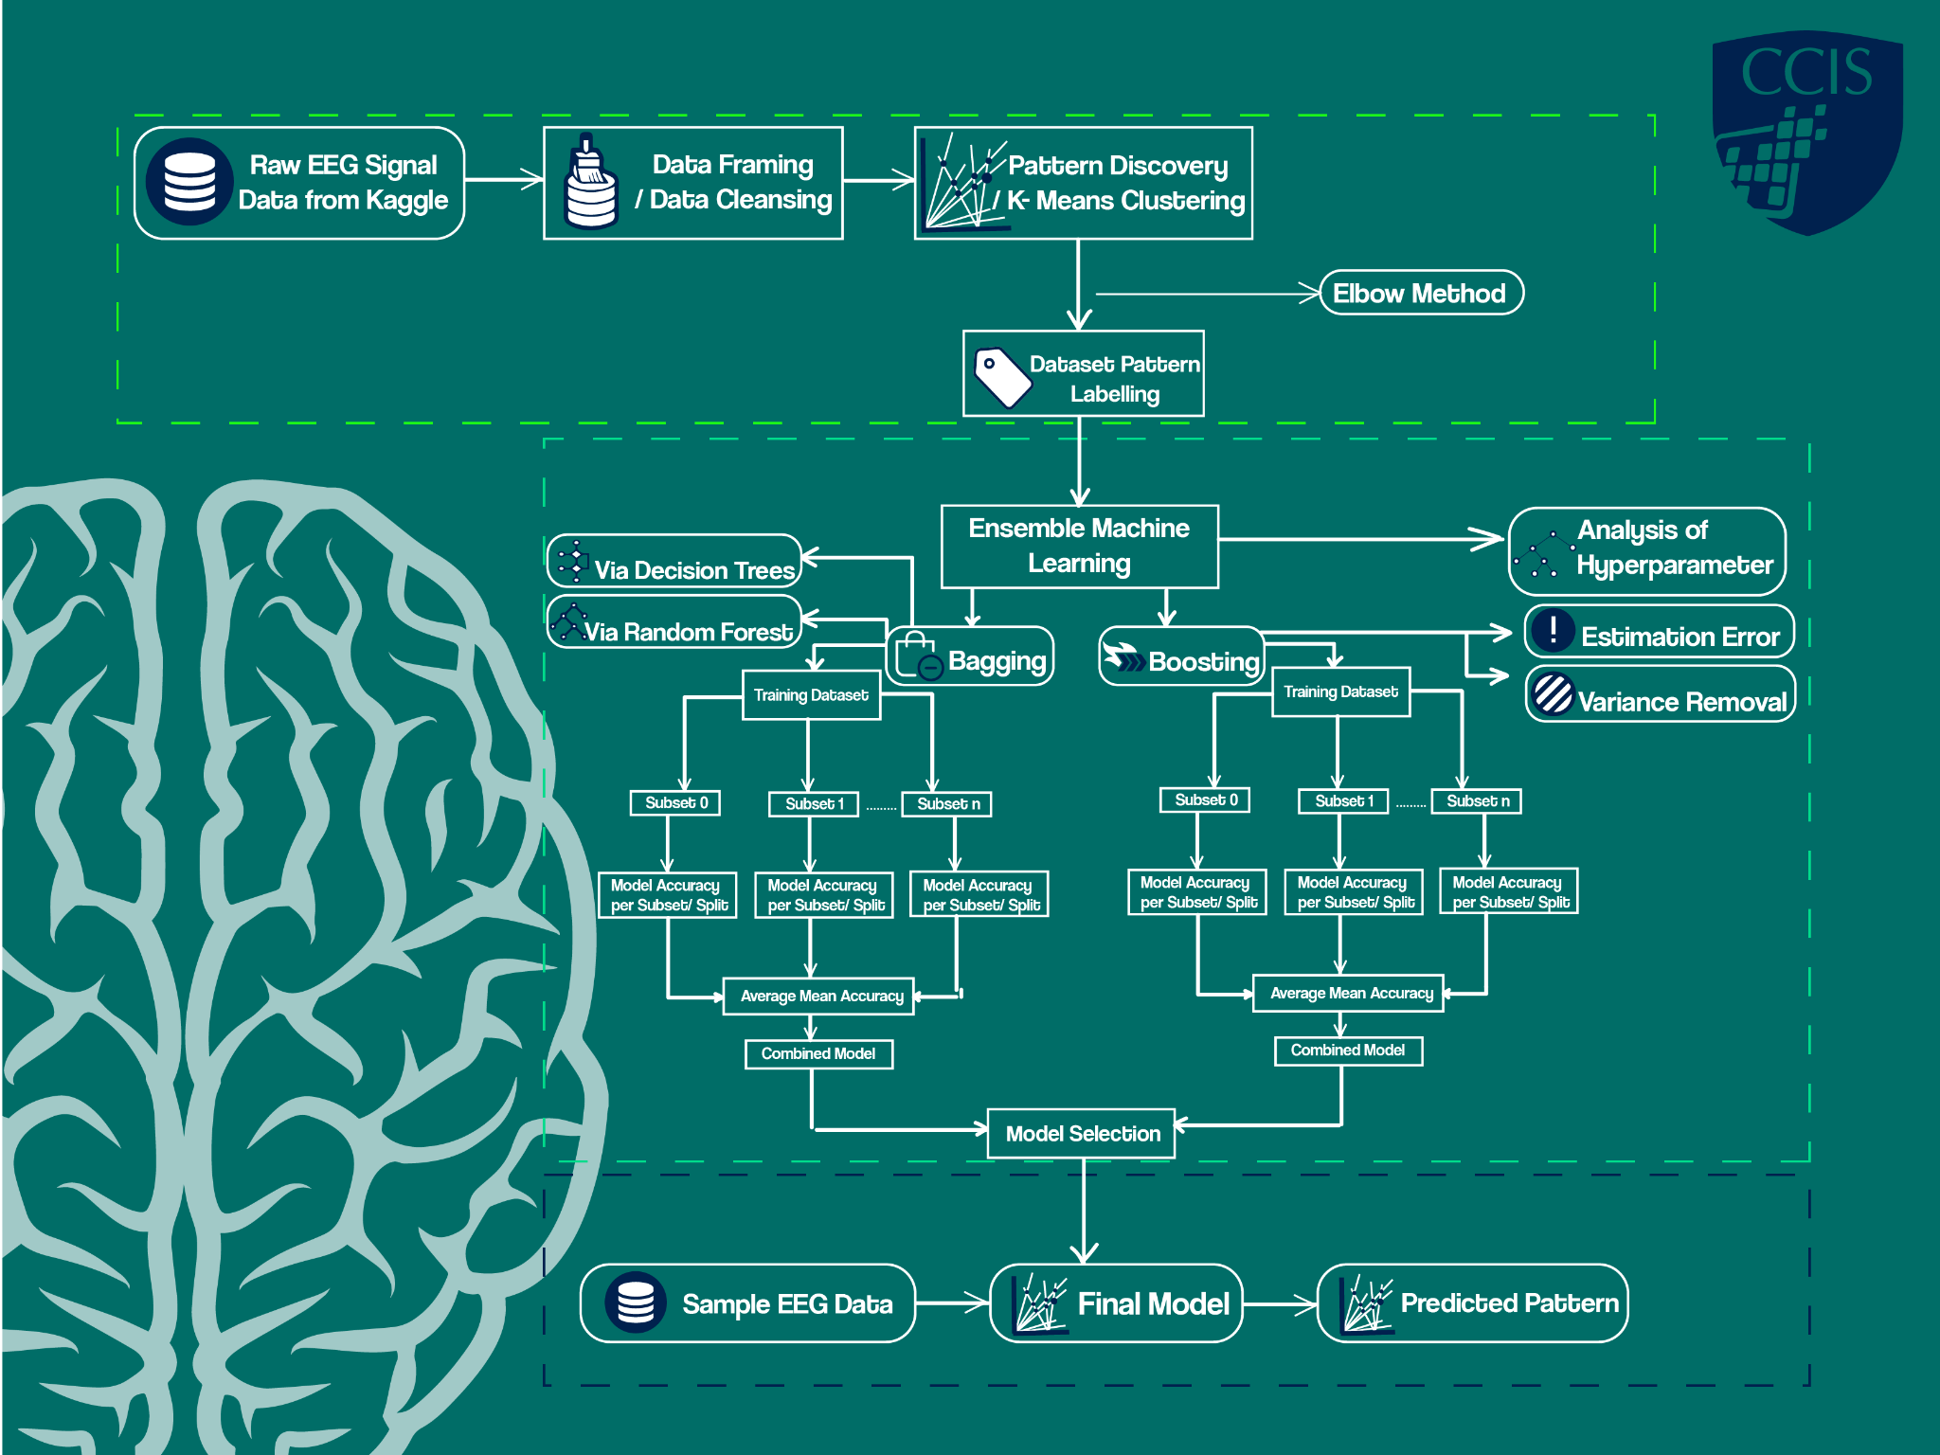

*Figure 1.* Research Framework.

The research framework of the study is divided into three main components: ***(1)*** ***Data collection Processing and Pattern Discovery (2) Ensemble Learning Modelling (3) Pattern Predictive Model.***

In data collection and preprocessing, datasets will be acquired from Kaggle, a leading data source of reliable datasets for experiments and data mining. Once acquired, the dataset will undergo cleansing, combining, and pre-processing, which involves a parametric model-based technique called Auto-aggressive model. This will revalidate the EEG data especially the EEG signals to remove leakages. After this, the processed dataset can be subjected to clustering technique via K-means. In this stage, the patterns will be discovered by identifying groups or clusters, and identified groups will be labelled and assigned as new features in the dataset.

Under the Ensemble Machine Learning, the labelled dataset will be divided into n datasets. These datasets will be subjected to ensemble processes which are Bagging and Boosting. The goal of the ensemble method is to combine the predictions of several base estimators built with a given learning algorithm in order to improve generalizability and robustness over a single estimator. Several learners will be produced in bagging using a selected technique (for example: Decision Trees). The result models using the selected technique for all dataset n will be combined, and then sequentially reconstructed by boosting in the model combiner.

The last component of the framework will allow the use of external datasets to be tested in the final model. Here, a separate dataset (could be from Kaggle, actual sensor if there’s any, or other datasource) will be utilized as input to the predictive model. The model will be able to determine or predict the group pattern where each record in the input dataset belongs to. This can provide a possible attention pattern of the records fed.

# **Review of Related Literature**

## EEG (Electroencephalogram)

Electroencephalogram is a pictorial technique used for studying the functional state of the brain. In this technique multiple electrodes are placed according to the 10-20 system over the scalp. EEG computes voltage deviation resulting from ionic current present in the neurons of the brain. EEG recording normally not only contains electrical signals further which will be subtracted by a differential amplifier. Generally, EEG is used to identify electrical problems in the electrical activity of the brain which are associated with certain disorders. The recorded activity that is not of cerebral origin is termed as artifacts. The systematic approach of recognition and elimination of artifacts is an internal working of the brain (Kumar, 2019).

An existing study which utilized EEG based computer interface to measure the attention level of users. The researchers presented an experiment to study the impact of real-time attention-based neurofeedback in improving the performance and average attention of users while performing a reading comprehension task. This experiment resulted in an improvement in the average attention as well as improvement in the test scores of the users (Sethi et al., 2018).

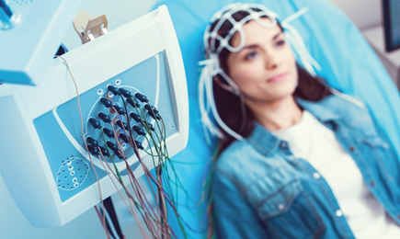

*Figure 2.* Actual Electroencephalography Process.

### EEG Frequency range

Based on frequency range, the five wavebands are as follows (Noachtar et al., 1999):

* α activity: electromagnetic waves ranging between 8 and 13 Hz in frequency, and between 30 and 50 μV in amplitude. This type of periodic wave is produced in the parietal and occipital regions of the brain when in a state of consciousness, quiet, or at rest. When thinking, blinking, or otherwise stimulated, α waves disappear. This is known as an alpha block.
* β activity: electromagnetic waves ranging between 14 and 30 Hz in frequency, and between 5 and 20 μV in amplitude. This type of activity occurs in the frontal region when people are conscious and alert. These waves are particularly apparent when a person is thinking or receiving sensory stimulation.
* θ activity: electromagnetic waves ranging between 4 and 7 Hz in frequency, with an amplitude of less than 30 μV. This activity primarily occurs in the parietal and temporal regions of the brain. Such waves are produced when people experience emotional pressure, interruptions of consciousness, or deep physical relaxation.
* δ activity: electromagnetic waves ranging between 0.5 and 3 Hz in frequency, and between 100 and 200 μV in amplitude. In a conscious state, most adults exhibit almost no δ activity; instead, this activity occurs when in a deep sleep, unconscious, anesthetized, or lacking oxygen.
* γ activity: electromagnetic waves ranging between 31 and 50 Hz in frequency, and between 5 and 10 μV in amplitude. Recent studies have found that γ activity is related to selective attention. Other studies have also highlighted that this activity is related to cognition and perceptual activity.

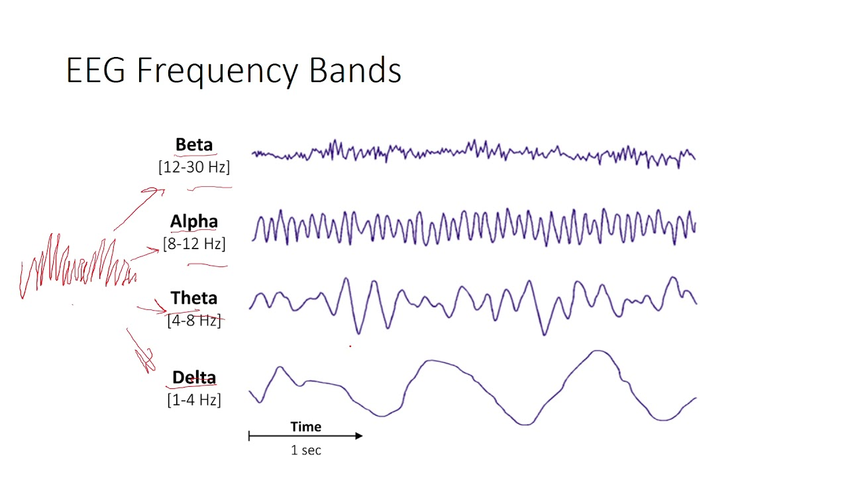

*Figure 3.* EEG Frequency Bands.

### EEG Datasets

As electroencephalography (EEG) studies continue to flourish, datasets have become readily available for further studies from scientific communities such as Kaggle. An example dataset would be of the study conducted by Wang et al. (2013) of which collected the four main wavebands of ten students each watching ten videos, but also contained features such as age, ethnicity, gender and gamma waves, but were unused in their study of confused students. Another dataset available was collected from the study of Chuang et al. (2015) where 2 different groups of about 15 people were each presented two different stimuli while EEG data was being collected, along with some metadata related to the presented stimuli. Both these datasets were posted at Kaggle and have been readily discussed and referenced to other various classifications made using EEG.

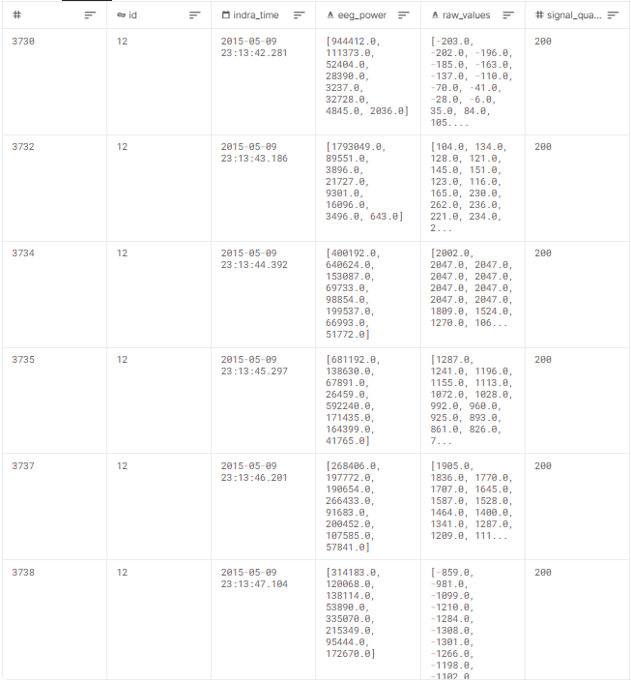

*Figure 4.* Sample Dataset using EEG from Kaggle.

**Identification of the number of Iterations in K-Means**

A fundamental step for any unsupervised algorithm is to determine the optimal number of clusters into which the data may be clustered. The Elbow Method is one of the most efficient methods to determine this optimal value K.

The Elbow Method, a visual method which is done by increasing the k-value by 1 starting with k=2. At some value fork the cost drops dramatically, and after that it reaches a plateau when increased further.

This is detected by observing a change in the slope between points in a graph of the within cluster sum of squared errors (SSE) versus the corresponding number of clusters.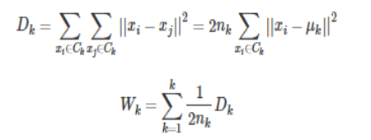

*equation (3.1) Elbow Method Formula*

Where k is the number of clusters, nr is the number of points in cluster r and Dr is the sum of distances between all points in a cluster. To see what I mean let’s take an example with three well separated clusters, and see what happens to the average internal sum of squares (Wk) as the number of clusters increases.

A study assessed the smokers’ quitting behavior patterns for multi-level intervention of a smoking cessation program. With the use of the Elbow Method the researchers stated that Young professionals who smoke casually or socially. A casual smoking person belonging to this cluster is usually triggered by peer pressure. This behavior is driven by the fact that they are most likely socially active and have access to places where smoking among young people with professional jobs is prevalent. Predominant Female.Clusters produced using K-means (via Elbow Method) were categorized into four different labels (Barrameda, Domondon, et. Al, 2021).

## K Means

K-Means clustering is a popular unsupervised learning method which is used when you have unlabeled data. It consists of two simple steps: first is to randomly choose k centroids for k clusters. Second is to separate the input data into k disjoint clusters according to the distance between each data instance and the k chosen centroids. Its simplicity and fast computation clustering make it easy to implement.

A previous study wherein a multi-scale K-means algorithm to discriminate epileptic EEGs from healthy EEGs was done using this learning method. The study combines several continuous EEG data points as a scale central area to make the centroid choice more robust than that of the K-means algorithm (Zhu, Li, Wen, Wang, Zhong, 2013).

Predictive K-Means (PKMMV, PKMSNB): (i) PKMVM corresponds to the Predictive K-Means described in Algorithm 1 where prediction is done according to the Majority Vote; (ii) PKMSNB corresponds to the Predictive K-Means described in Algorithm 1 where prediction is done according to a local classification model (Lemaire, Gay, 2019).

Unsupervised K-Means (KMMV) is the usual unsupervised K-Means with prediction done using the Majority Vote in each cluster. This classifier is given for comparison as a baseline method (Lemaire, Gay, 2019).

## Ensemble Machine Learning

Ensemble Machine Learning combines several base models in order to produce one optimal predictive model. They are defined as statistical and computational learning procedures. They are in sync with the human social learning of trying different opinions before making any final decision. Sets of learning machines are used to combine choices and provide more robust and accurate predictions on controlled and unattended learning problems (Soni, 2020).

A study which focuses on prediction of Diabetes Mellitus used ensemble machine learning technique. Wherein a dataset was fed to an ensemble model with principal component analysis and K-means clustering. This ensemble method produced only eight incorrectly classified instances, which was lowest compared to other methods. The study also showed that ensemble classifier models performed better than the base classifiers alone. Its result was compared with the same Dataset being applied on specific methods like random forest, Support Vector Machine, Decision Tree, Multilayer perceptron, and Naïve Bayes classification methods. All methods were run using 10k fold cross-validation (Soni, 2020).

Due to today's progressive technology, lots of ensemble learning techniques are available to be used but these two techniques namely Bagging and Boosting are the most widely used methods. BAGGing, or Bootstrap Aggregating gets its name from the combination of bootstrapping and aggregation to form one ensemble model. Given a sample of data, multiple bootstrapped subsamples are pulled. A decision tree is then formed on each of the bootstrapped samples. After each subsample decision tree has been formed, an algorithm is used to aggregate over the decision trees to form the most efficient predictor. Bagging tries to remove the instability of learning techniques by a way of simulating a method defined before applying in a certain training set. The original training data is modified by removing some samples and duplicating the others instead of sampling a new training dataset each time. Random sample is applied on instances from the original dataset with replacement to generate a new dataset. This sampling process necessarily removes some of the instances and replicates the others. Bagging only resamples the native training data instead of generating autonomous datasets from the domain. The datasets obtained by resampling vary from each other but are definitely not independent because one dataset is the base for all of them. Nevertheless, it seems that bagging generates a combined model that usually performs better than the single model made from the native training data and is never significantly worse (Jukic, Saracevic, Suvasi, Kevric, 2020).

## 

## 

## 

## 

## 

## 

## 

## 

## 

## 

*Figure 5.* Bagging Visualization Process.

Figure 2 shows that given a Dataset, bootstrapped subsamples are pulled. A Decision Tree is formed on each bootstrapped sample. The results of each tree are aggregated to yield the strongest, most accurate predictor.

On the other hand, boosting, this technique’s concept of learning relies on each of the trees learning from mistakes of the previous tree and trying to minimize the residual error as it keeps moving forward sequentially. Boosting learning rate is used as a hyper parameter in boosting methods as each of the trees learns from previous iterations. This technique also helps reduce both bias and variance.

### AdaBoost

Boosting refers to a general and provably effective method of producing a very accurate classifier by combining rough and moderately inaccurate rules of thumb. An example would be building an e-mail filter that can distinguish spam from non-spam. Examples of both spam and non-spam emails should be gathered as many as possible. A classifier would then be trained using these examples and their labels. The trained classifier, or prediction rule, would then be used to filter the email, but you would still get spam despite these. This is when rules of thumb should be established, like “if email contains ‘Prince of Nigeria’ then classify as spam”. Combining moderately inaccurate rules of thumb like these with trained classifiers would then produce a very accurate classifier (Corso, 2008).  
 It is an efficient instrument for improving the predicting ability of learning systems and a most typical method in coordinating learning and was first suggested in 1990 by Freund and Schapire. However, it had two main problems: adjusting the training set to enable weak classifiers to be conducted training upon, and combining them into a strong one, which is gained through training. This is when Freund and Schapire introduced adaptive boosting (AdaBoost) algorithm in 1995 in order to solve these problems. On later innovations, the algorithm could change voting-weights and solved many practical problems of the early Boosting algorithm.

It was further innovated to be able to solve multi-class problems if there is a big category, and later a confidence prediction was introduced so as to improve the quality of boosting (Chengsheng et al., 2017; Schapire and Singer, 1999).

A study performed wherein Chaos Generic Algorithm and Adaboost Algorithm were compared using aggregate various classifiers. According to Mahilraj et al., (2016), Adaboost has limited features when comparing it with Chaos Generic Algorithm. They also concluded that Adaboost is sensitive to noisy data hence it is less fit for optimization problems. The Adaboost and Chaos Genetic Algorithm were effective and minimized the error ratings when comparing with the traditional algorithms. The Adaboost algorithm is effective to reduce the basic and more complex recognition problems (Mahilraj et al., 2016).

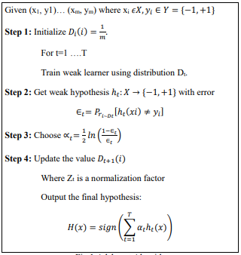

*Figure 6.* Adaboost Algorithm.

## Scikit-Learn

Scikit-Learn is a free machine learning library for Python. It features various algorithms like support vector machines, random forests, and k-neighbours, it also supports Python numerical and scientific libraries like Numpy and SciPy.

Scikit-learn harnesses these prosperous surroundings to furnish trendy implementations of many well recognized computers getting to know algorithms, whilst preserving an easy-to-use interface tightly integrated with the Python language. These solutions the developing want for statistical facts evaluation by non-specialists in the software program and internet industries, as properly as in fields outside of computer-science, such as biology or physics (Chary, 2020).

Scikit-learn’s k-means algorithm is applied in pure Python. Its overall performance is limited by the reality that numpy’s array operations take a couple of passes over data (Chary, 2020).

## Sustained Attention

Sustained attention is a process that enables the maintenance of response persistence and continuous effort over extended periods of time. Performing attention-related tasks in real life involves the need to ignore a variety of distractions and inhibit attention shifts to irrelevant activities (Ko, Komarov, Hairston, Jung, Lin, 2017).

A previous study investigates electroencephalography (EEG) spectral changes during a sustained attention task within a real classroom environment. Sorting their EEG spectra with respect to response times, indicated the level of alertness to randomly introduced visual stimuli, revealed significant changes in the brain oscillation patterns (Ko, Komarov, Hairston, Jung, Lin, 2017).

## Audiovisual Stimulus / Tools

Audiovisual stimuli or tools significantly enhance methods of instruction, as learners are usually divided into visual or word-oriented students. It can include everything seen and heard in the classroom from words and gestures, to the use of the chalkboard, films and videos. Learning to use these tools to the teacher’s advantage can add variety, impact and power to their teaching (Clawson, 2018).

Audiovisual tools extend experience by bringing culture and climates into the classroom through the aid of slides, films and projectors, and also serves as a clear source of information by playing a major role of making learning permanent and allowing students to visualize what is learned (Ashave & Igyuve, 2013).

Audiovisual tools facilitate and assist the regular and traditional teaching session by helping maintain and retain the student’s attention. When a teacher gives students maximum exposure as well as different perspectives using audiovisual tools in a lecture, students can then easily comprehend said lecture (Akram et al., 2012). Audiovisual tools also help in improving conversational and pronunciation skills, as well as stimulating thinking and improving the learning environment in a classroom (Matthew et al., 2013).

A study by Rasul et al. (2011) analyzed the effectiveness of audiovisual aids at a university level and found that the majority of the teachers agreed that audiovisual tools help in the teaching process. A majority of the students also agreed that audiovisual tools help in the learning process.

**Audio-Visual Types and Video Types**

The usage of audio-visual tools in the teaching and learning process have seen a rapid increase due to the benefits of using them, particularly video. Images also have a comparable role to audio-visual assistance.

There are two types of media: audio-visual and visible media. It is worth noting that available audio-visual media is more readily available than other forms of media. There are also more advantages with audio-visual than with visual or audio media. To grab a students' attention and expand their knowledge, audio-visual, for example, might portray abstract objects or non-verbal languages.

By using audio-visual aids, according to Mathew and Alidmat (2013), students were observed to have a better comprehension of the subject areas compared to stale classrooms, which used no audio-visual aids. When it comes to changing the traditional ways of teaching, audio-visual can be one of the most effective tools a teacher can utilize.

Aside from that, according to Arsyad (2014), video can be used in a variety of ways. Teachers can walk in and out of the process at any time; they can stop, start, repeat, and rewind the process numerous times which was similar to Asmani's study. Instructors can quickly replay, or run-in slow motion used video rather than used television in order to let the kids pay attention, according to Asmani (2011).

According to Lalian (2018), the use and selection of relevant and effective learning material in the learning process has a significant impact and thus also plays an important role in a student's success in school. By touching the cognitive, emotional, and psychomotor elements of the learning process, video media has become one of the most effective and practical learning media in education.

Lalian (2018) also stated that, learning films, which also touch the cognitive, emotional and psychomotor elements of the learning process, also have a good impact on students. A student’s comprehension or cognitive element depends also on the attitudes and emotions that can be influenced by the film, which were found to be a film’s most effective features. Individual learning that utilized a computer was also used to practice the psychomotor parts, which are difficult to exercise. The students' enthusiasm for studying were boosted by the use of video as a learning medium. Learners became more enthused about the content and paid greater attention to it.

**Audio Visual / Types**

To begin with, Madhuri (2013) stated that video is a useful tool for effective communication, education and learning. Film and video were also found to be used in the same way. It enabled stop and start, replaying segments, and even slow motion for playbacks. Videos also depicted the motion of the information stored inside as well as moving images. In today's world, educational video cassettes and the internet are readily available. On the other hand, educational CDs can be made on any subject topic or curriculum.

Audio Visual Aids can be classified purely on the basis of sensory perception, because the majority of people's perceptions are derived from direct sensory touch. In light of this, it can be divided into three primary categories:

1. Radio, tape recorder, gramophone, linguaphone, audio cassette player, and language laboratory are all examples of audio aids.

2. Charts, black-and-white boards, maps, pictures, models, textbooks, slide projectors, transparency, flashcards, printed materials, and presentations are all types of visual aids.

3. LCD projectors, film projectors, televisions, computers, VCD players, virtual classrooms, and multimedia are all examples of audiovisual aids.

In this study the researchers used the third primary type of audiovisual aids, as all used materials were videos. Since other related literature were found to also have varying types of classifications for different audio-visual types, and found to have no standards for subcategories besides the primary types, the researchers needed new categories which were founded based on the provided videos for the study. Thus, the following audio-visual types were created which are: (1) AV with teacher-aid which is composed of a video wherein a teacher is present speaking throughout the video teaching mathematics and physics. (2) AV without teacher aid, wherein there is no teacher present but his calculations and solutions are present with both audio and visual aids. (3) AV with Illustration and Teacher Aid, this video type is composed of the instructor itself, calculations, and both audio and visual aids. (4) AV with the use of Media Tools, his video type contains the media tool respective to the class the instructor is teaching, this also includes audio and visual aids.

## E-Learning

Web-based learning or E-Learning has been introduced as a tool in the learning process in most universities worldwide. According to Li & Masters (2009), the “E” in E-Learning does not stand for electronic, it should be an abbreviation for “evolving, enhanced, everywhere, every time, and everybody”. This statement by Li & Masters shows most, if not all, the advantages of E-Learning for both learners and educators. E-Learning has also transformed the educational sector by enabling both learners and educators to share information and data in a relatively easy way (El-Seoud et al., 2014).

However, E-Learning poses a problem when there is insufficient teacher knowledge and skills to use education technologies present and lack of feedback on its implementation. Due to such, many studies have tried to improve E-Learning by collecting data through non-invasive methods, such as EEG.The study by Sethi et al. (2018) developed a tool using EEG-based feedback to improve focus on E-Learning. Another study by Wang et al. (2013) used EEG to collect data of student’s attention while watching videos of Massively Open Online Courses (MOOCs).

## 

# **Methodology**

## Research Design

The study is a quantitative research since the study deals with a large amount of data that represents a population. According to Sheard (2018) quantitative research, in contrast to qualitative research, deals with data that are numerical or that can be converted into numbers. The basic methods used to investigate numerical data are called “Statistics”. Statistical techniques are concerned with the organization, analysis, interpretation of numerical data. Statistics is a huge area of study with wide applications across many disciplines, including information systems and other areas of information research. In this study, a quantitative approach is more than based on statistical analysis, but rather with the use of different machine learning techniques and processes.

**Research Locale**

There is no specific target locale however for testing or experimentation since the dataset is already pre-recorded. This study focused on the use of pre-recorded data which were gathered and collected from Language Technologies Institute Carnegie Mellon University in Pittsburgh, Pennsylvania.

**Population of Study/Sampling Design**

According to Siuly, Siuly & Li, Yan & Wen, Peng (2019), for a given population, if the sample size is adequately taken as a whole, then it can tell the characteristics of the population. This is based on their study about Classification of EEG Signals Using Sampling Techniques where the experimental data used are publicly available as well. As sampling is a representative part of a population, it is a natural expectation that it could be used to represent the EEG signal of the human body.

In sampling techniques for big data analysis ( Kim, Jae & Wang, Zhonglei., 2018), inverse sampling were used which contains two phases: First was by incorporating auxiliary information from external sources, and the second one borrowed the idea of data integration by combining the big data sample with an independent probability sample. In this study, only the auxiliary information from external sources is be used. According to the study mentioned, unlike the classical two-phase sampling, the first-phase sample is the big data itself, and we have no control over it but to use it.

This study used an actual dataset has been collected from Kaggle. The procedures in collecting this kind of data were knowing the nature of the data source and what it can contribute in the study. The EEG dataset collected was based on actual recording of EEG signals from 10 college students of different ethnicity while watching MOOC video clips. These online education videos were divided into two main categories: non-confusing and confusing videos. There were 20 videos in total, 10 for each category. Each video was about two (2) minutes long and also the videos were chopped within the two-minute clip in the middle of the topic to make the videos more confusing. The students wore a single-channel wireless MindSet that measured activity over the frontal lobe. The MindSet measures voltage between an electrode resting on the forehead and two electrodes each in contact with an ear.

The total data gathered contained 12812 rows, but can only be seen as 100 data points, due to having ten students watching ten videos. Each data point consists of 120+ rows, sampled every 0.5 seconds, and can be considered as one to a one-minute video. Signals of higher frequency were reported as the mean value during each 0.5 seconds.

## Data Gathering tools

**Kaggle**

For the data gathering tool, the researchers used Kaggle. It is the world's largest data science community with powerful tools and resources for data science goals. Kaggle allows data scientists to utilize datasets of different types and create new datasets available for testing. Figure 3 shows the Kaggle Environment.

Kaggle has been utilized in studies such as model prediction and the likes. According to Kowald et. al, 2019, there is actually a lack of an open dataset for the evaluation of tripartite recommendations in data markets. Moreover, Cavanagh JF, Napolitano A, Wu C, Mueen A., 2017 solidified this by mentioning that a lack of uniform diagnostic schema, like EEG sources, is still a known gap nowadays. In fact, Patient-specific online repositories tend not to have EEG data. While some sites may contain both EEG data and patient groups, they sometimes require formal requests and selective processes for data acquisition, and tend to not include matched controls. Kaggle reduces these aforementioned gaps by providing readily accessible data with complete requisites. Therefore, the study proposes the use of the open Meta Kaggle dataset of the well-known data science portal Kaggle.

Kaggle has a feature called “Usability” wherein a dataset is rated from 1-10. One being the lowest and ten being the highest. With these users who chose to procure these datasets learns if the dataset is applicable and reliable to be used in their proposed studies.

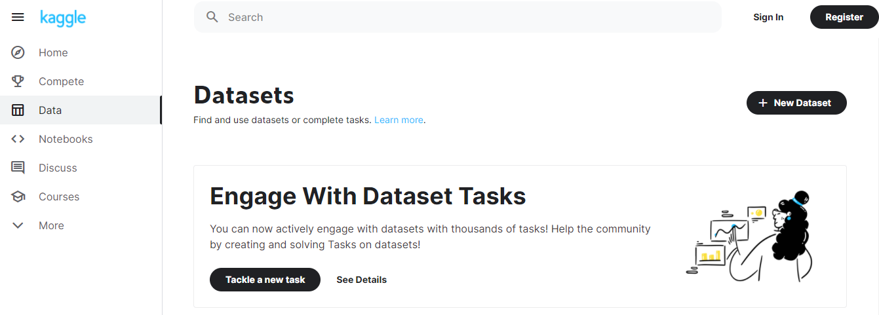

*Figure 7.* Kaggle Environment.

The researchers from Kaggle used The NeuroSky “MindSet,” an audio headset equipped with a single-channel EEG sensor, to gather EEG signals from the students, while each of the students’ watched videos, of which was considered audiovisual stimulus.

**Scikit-Learn package in Python**

A package dedicated to perform numerical analysis, graphs, and machine learning techniques are used by the proponents in performing the parametric preprocessing and the methods involved in Ensemble Machine Learning.

Scikit-learn is a module from Python that is used in integrating a wide range of machine learning algorithms for medium-scale supervised and unsupervised problems. This package focuses on bringing machine learning to non-specialists using a general-purpose high-level language. Emphasis is put on ease of use, performance, documentation, and API consistency. It has minimal dependencies and is distributed under the simplified BSD license, encouraging its use in both academic and commercial settings. A sample screenshot of scikit installation in python via command line client can be seen in Figure 2.1.

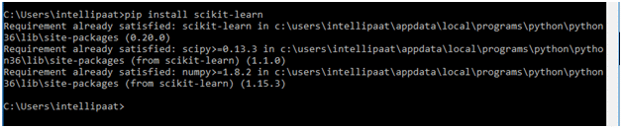  
 *Figure 8.* scikit-learn installation in Python.

**Jupyter and Anaconda Environments**

For the environment and utilities in exploring and facilitating scikit-learn functions, Jupyter alongside Anaconda are utilized. Both Jupyter and Anaconda are open-source software packages that can assist in performing machine learning processes including ensemble machine learning. Several testing environments were created using jupyter to align scikit packages and related libraries as seen in Figure 3.2.

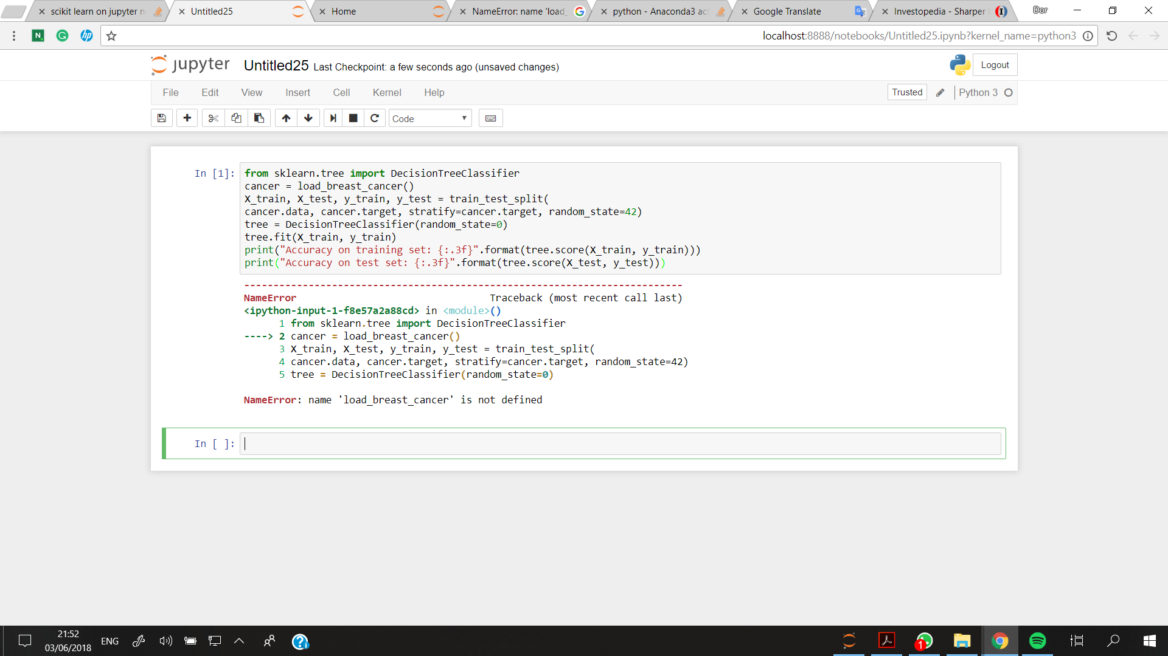

*Figure 9*. Jupyter Environment via Anaconda Command.

## Data Gathering Procedure

The following are followed as the data gathering procedures of this study:

1. A Kaggle account has been created in order to obtain pre-recorded dataset from Kaggle.Specifically, the dataset are collected from the data section of Kaggle that can be found through this link: [*https://www.kaggle.com/wanghaohan/confused-eeg*](https://www.kaggle.com/wanghaohan/confused-eeg)
2. The collected datasets are subjected to pre-processing, which will involve combining of datasets and their data framing. The computation shall be performed in python using the numpy library from scikit package and the pandas.dataframe.
3. After frequencies are checked and data are adjusted, Final Dataset is prepared to be format-ready for scikit-learn in python for ensemble machine learning.
4. Analysis of the final dataset will be performed using the selected Python environment via scikit-learn:
   1. Perform K-means clustering and label each record in the dataset based on the groups formed. A new final labelled dataset will be formed.
   2. Perform Bagging Procedure for the labelled dataset to create n datasets using applicable techniques:
      1. Random Forest and/or Decision Trees
   3. Perform Boosting Procedure to remove errors and variance to produce the final model via:
      1. AdaBoost

## Data Analysis Plan

The following procedures are followed in performing Data Analysis:

**Pre-recorded Dataset from Kaggle**

As mentioned in Data Gathering Procedure, pre-recorded dataset from Kaggle is acquired and pre-processed. Although the datasets are ready, these are downloaded and combined first. Some of the fields, including the trivialized features are separately recorded as well in Kaggle. This is tabulated again in excel for proper preparation in pre-processing.

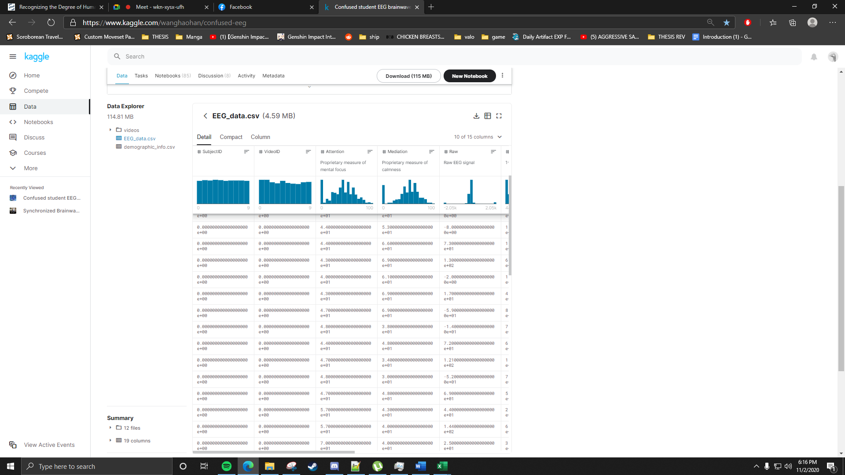   
 *Figure 10.* Kaggle Account in Data View of pre-recorded dataset.

Two datasets are acquired from Kaggle: (1) EEG dataset and (2) Demographics with trivialized features. All are in the form of CSV files. Table 3.0 shows the EEG Features with additional gamma signals, trivialized features, and additional features which are used in the study. The additional feature are based on the sub types of AV(Audio-Visual) Stimulus used: *(1) AV with Teacher Aid, (2) AV without Teacher Aid, (3) AV with Illustration and Teacher Aid (4), and AV with the use of Media Tools.*

Table 1

*EEG Dataset Features/Attributes from Kaggle*

|  |  |  |
| --- | --- | --- |
| Feature/Attribute | Datatype | Dataset Source |
| SubjectID | Numeric | EEG,Demographic |
| EEG Signals, Additional Gamma Signals | Alpha1 ,Alpha2, Beta1, Beta2, Delta, Theta , Gamma1, Gamma2 | EEG |
| Attention | Numeric(Frequency) | EEG |
| Meditation | Numeric(Frequency) | EEG |
| VideoType | Nominal(Confusing/ NotConfusing) | EEG |
| Age | Numeric | Demographic |
| Gender | Nominal | Demographic |
| Ethnicity | Nominal | Demographic |
| AVStimulus | Nominal | Additional Feature |

**Clustering via K-Means**

After the pre-processing via auto aggressive method, the dataset is subjected to K-means clustering in order to identify interesting groups or patterns with respect to attention. The identified clusters/groups are used to label each record in the dataset for ensemble machine learning.

The k-means algorithm is one of the simplest yet most commonly used clustering algorithms. It seeks to partition *m* instances (X1, . . . Xm) into K groups (B1, . . . , BK) so that instances which are close are assigned to the same cluster while clusters are as dissimilar as possible. The objective function can be defined as:

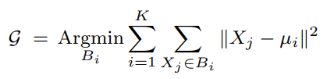

Equation(2) K-means objective function

where µi are the centers of clusters Bi and we consider the Euclidean distance. Predictive clustering adds the constraints of maximizing cluster purity (i.e. instances in a cluster should share the same label). In addition, the goal is to provide results that are easy to interpret by the end users. The objective function of Equation (1) needs to be modified accordingly. One approach is to modify the distance used in conventional clustering algorithms in order to incorporate information about the class of the instances. (Lemaire, Gay, 2019)

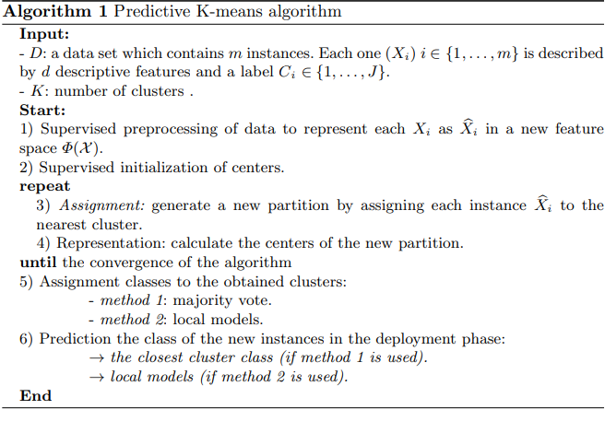

*Figure 11.* K-means Algorithm.

**Identification of the number of Iterations in K-Means**

For frequency data such as the EEG signals, a methodology called Elbow Methodology is performed during Clustering. The basic idea of the Elbow Methodology is to determine the optimal number of clusters in k-means clustering. The elbow method plots the value of the cost function produced by different values of k.

*equation (3.1) Elbow Method Formula*

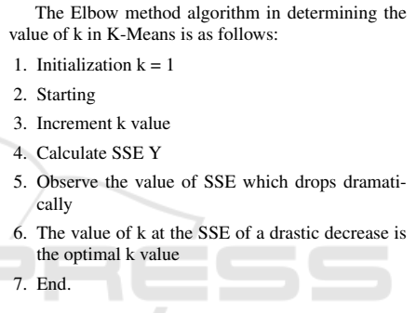

*Figure 12.* Elbow Method Algorithm Process.

**Ensemble Machine Learning**

For Ensemble Machine Learning, Bagging and Boosting are performed. Ensemble Learning is done once the dataset is labelled by pattern groups/clusters formed during clustering. Ensemble is done using the scikit-learn package of Python. For Bagging, a decision tree and Random Forest classification are performed for n data sets/subsets. The visualization of how dataset can be divided into subsets in order to provide final model base on combined models can be seen in Figure 13.

**Bagging Process**

1. Multiple subsets are created from the original dataset
2. A base model is created on each of these subsets.
3. The models run in parallel and are independent of each other.
4. The final predictions are determined by combining the predictions from all the models

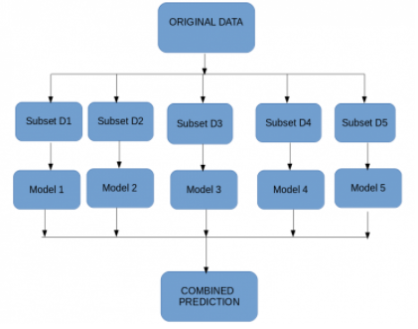

*Figure 13.* Bagging Visualization.

**Analysis of Hyperparameter for Number of estimators in Bagging**

It is important to know the hyperparameter for the Bagging algorithm. This hyperparameter is the number of estimators. Typically, the number of estimators is increased until the model performance stabilizes or when acceptable high accuracy is achieved.

For example, if a Decision Tree is used, the number of trees can be set via the “*n_estimators*” argument and defaults to 100.

For this process, the analysis are based on intuition by graphing the accuracy value against the number of subsets (Brownlee, J., 2020). The key is to explore the number of selected estimator n’s and graph it and see where it stabilizes as seen in Figure 3.3. A sample process of how Bagging can be facilitated in scikit is seen in Figure 3.4 Although the process is done in Python, analysis of hyperparameter n is manually checked and graphed until the final model is produced.

In this study, n_estimator (in the form of the number of trees) used starts at 50 and defaults to 100. Model Accuracy per increase in n_estimator is be graphed and the model with highest accuracy is selected.

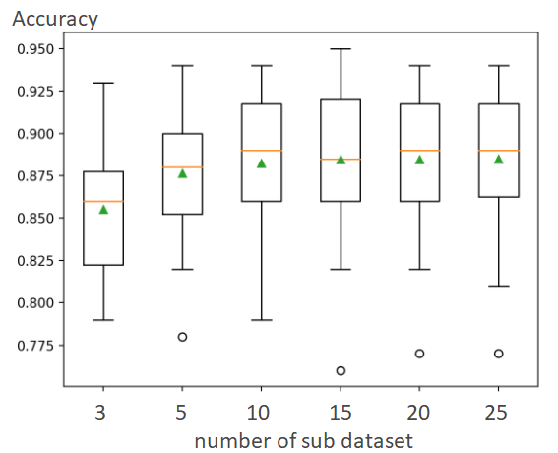

*Figure 14.* Analysis via Hyperparameter n.

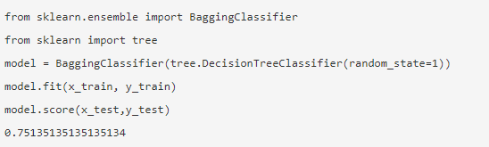  
*Figure 15.* Sample Bagging Process via scikit.

**Boosting Process**

Boosting is a sequential process, where each subsequent model attempts to correct the errors of the previous model. The succeeding models are dependent on the previous model. (Kumar, A., 2020)

1. A subset is created from the original dataset.
2. Initially, all data points are given equal weights.
3. A base model is created on this subset.
4. This model is used to make predictions on the whole dataset.
5. Errors are calculated using the actual values and predicted values.
6. The observations which are incorrectly classified/ predicted, are given higher weights.
7. Another model is created and predictions are made on the dataset.  
   (This model tries to correct the errors from the previous model)
8. Similarly, multiple models are created, each correcting the errors of the previous model.
9. The final model (strong learner) is the weighted mean of all the models (weak learners).

The formulas used to analyze the Boosting processes mentioned are as follows:

**Estimation Error Computation**For each given n_estimator (hyperparameter), errors are iteratively recorded and plotted. This allows viewing of sudden error spikes throughout the n_estimator value. The study used the estimation_error function from the AdaBoostClassifier in python. An example plotting can be viewed in Figure 16.  
  
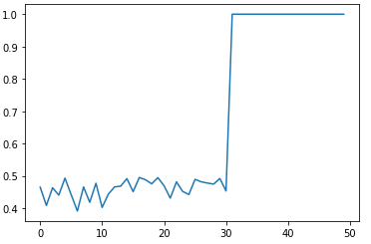

*Figure 16.* Sample AdaBoost Plotting.

**Total Error (TE) = $\sum_{n}^{e}{}error per classified record$**   
*equation (3)*

## Updating Weights

For incorrectly classified records, weights are computed to set higher priority in sequencing. The formula is seen in equation 4:

**New Sample Weight = Sample Weight * e^(Performance)** equation (4)

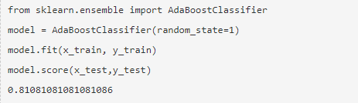

*Figure 17.* Sample Boosting via AdaBoost using scikit.

# 

# **Results and Discussion**

## Data Gathering

The data gathered for this study was from a Licensed public dataset from Kaggle which was published by Wang (2018). This data set contains EEG signal data from 10 college students while they watched MOOC video clips. These EEG signal data were procured via a device called NeuroSky MindSet which measures the voltage between an electrode resting on the forehead and two electrodes each in contact with an ear. However this data set which was procured was still raw and data cleansing needs to be done for it in order to be usable. This data set also contained values of 0 of some students in some videos, which was removed for this study, to increase its reliability during clustering.

## Data Preparation

In this study, the dataset to be used for clustering required the attributes of ethnicity, age and gender to be included before clustering, as these were needed to be able to find patterns with brainwaves. The required attributes were then added to the dataset along with the computations for the averages of the brainwaves. The videos used in the study were also categorized according to their corresponding AudioVisual Type which are :*(1) AV with Teacher Aid, (2) AV without Teacher Aid, (3) AV with Illustration and Teacher Aid (4), and AV with the use of Media Tools See Appendix H for the list of videos with corresponding AVType*

***Data Framing***

Following the EEG Analysis by Claesson, L. et.al (2017), the study used data framing in finalizing the dataset. The data can be structured in Python using Pandas. DataFrame and organize data according to individual records on the major index axis and AV Type on the minor index axis. This is the snippet of the process performed in Data Framing using Python.

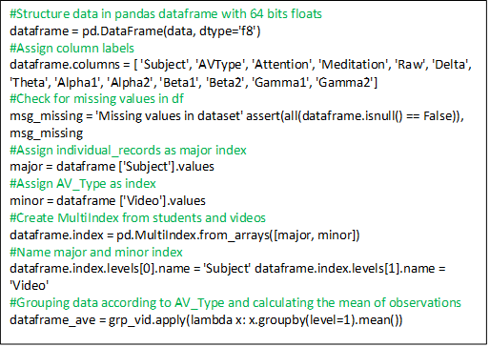

*Figure 18.* Code Snippet of Data Framing Process using Python.

Since the number of recorded time points are not equal for all videos of any AV Type on all individual records, the signal data can be averaged. The data points will then represent the overall brain activity for each student while watching the videos (Claesson, L. et.al., 2017).

After Data Framing, here is the final dataset with timepoints of brainwaves grouped and converted into Visual Brainwave representation: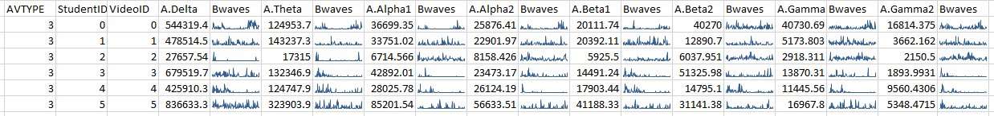



*Figure 19.* Sample Data of Dataset with Visual Brainwave representation.

**Clustering**

For clustering, Simple K-Means was implemented using WEKA. The Elbow Method was used for the selection of numbers of K, where the most optimal number of K is the point where results begin showing stability. In determining the optimal number of K, the Sum of Squared Errors (SSE) was noted per set number of clusters in WEKA. The start number of clusters was set to 2 and the SSE was noted down. A steep drop of the SSE then occurred after the set number of clusters was set to 3. Following this the SSE also stabilized, until the number of clusters was set to 6 and was chosen as K. Figure 4.0showed that it dropped at around 2 and 3 and then started to stabilize. Hence, the selected number of K was 6.

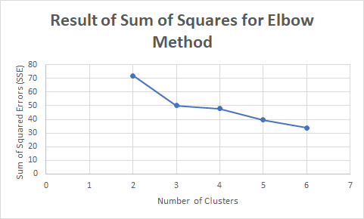

*Figure 20.* Result of Sum of Squares Elbow Method.

Using the dataset that was prepared for this study, clustering was conducted using K-Means with K set to 6. Since K was set to 6, the 6 clusters that were produced had a Sum of squared errors (SSE) of 33.7584.

Table 2

*Number of Clusters and SSE Data Table*

|  |  |  |
| --- | --- | --- |
| Number of Clusters | Sum of Squared Errors | Remarks (+-) |
| 2  3  4  5  6 | 72.07178199  50.23038627  47.7879389  39.62952194  33.75846389 | 0  21.84139572  2.44244737  8.15841696  5.87105805 |

After applying K-Means where K = 6 unto the finalized dataset, 6 clusters were formed with varying attributes, each cluster having predominant outliers which will be determined later on in this chapter.

Table 3

*Cluster Results from K-Means where K = 6*

|  |  |  |  |  |  |  |  |
| --- | --- | --- | --- | --- | --- | --- | --- |
| Attributes | Full Data | Cluster #0 | Cluster #1 | Cluster #2 | Cluster #3 | Cluster #4 | Cluster #5 |
| StudentID | 4.5 | 6 | 6 | 0.5 | 2 | 4 | 6.6667 |
| **AV Type** | 2.5056 | 2.5 | 2.7692 | 2.5 | 2 | 2.4444 | 2.5714 |
| **Ethnicity** | Han Chinese | English | Han Chinese | Han Chinese | Han Chinese | Han Chinese | Han Chinese |
| **Gender** | M | M | F | M | F | M | M |
| **Age** | 25.5281 | 31 | 26.7692 | 24.2143 | 24 | 24.9444 | 24.5 |
| **A.Delta** | 590513.4436 | 40514.5573 | 807680.6581 | 437846.6667 | 885717.4607 | 631032.233 | 908436.4808 |
| **A.Theta** | 159445.5028 | 19355.5755 | 222079.6725 | 123765.5075 | 165628.8669 | 150976.1955 | 280948.523 |
| **A.Alpha1** | 38593.6384 | 7802.8547 | 53948.6311 | 29041.8907 | 48629.5986 | 33380.7279 | 67833.5311 |
| **A.Alpha2** | 28155.8624 | 8212.9707 | 34840.7446 | 22085.8465 | 52048.8725 | 23107.8515 | 44583.8647 |
| **A.Beta1** | 20303.926 | 7979.9749 | 23534.2056 | 17934.0752 | 19144.3672 | 19775.9441 | 32022.6919 |
| **A.Beta2** | 24252.4378 | 8339.9904 | 24060.3957 | 15809.5104 | 55735.044 | 33761.4436 | 26964.2413 |
| **A.Gamma1** | 17006.5009 | 4581.5473 | 18672.3842 | 10207.9378 | 24724.8187 | 31477.0466 | 16018.8647 |
| **A.Gamma2** | 8289.297 | 3537.323 | 7554.392 | 6480.5887 | 3516.1382 | 16117.3232 | 7964.4268 |
| **A.Attention** | 46.3658 | 55.7293 | 43.9043 | 48.5774 | 43.2773 | 46.5804 | 38.5878 |
| **A.Mediation** | 53.0088 | 60.9399 | 50.4746 | 56.0502 | 52.4627 | 48.0101 | 50.2752 |

Table 3

*Cluster Description and Analysis*

|  |  |
| --- | --- |
| Cluster # | Description and Analysis |
| Cluster 0 | This cluster has the highest average attention  And mediation of all the given clusters, which translates to having the most focus / concentration and relaxation / calmness (according to Neurosky) while viewing the AV materials.  This cluster also has the lowest average brainwaves except on Gamma 2 across all clusters, which further translates to slower brain activity.  The cluster has the oldest (age) among the other clusters which according to Ruth Peters, translates to slower brain activity. (Peters, 2006) |
| Cluster 1 | This cluster has predominantly female clusters, and whose brainwave averages between the highest and lowest, with AVType closest to 3. |
| Cluster 2 | This cluster is predominantly male, contains lowest average theta brainwaves, and averages across other brainwaves.  This cluster also has the highest number of data points (28). |
| Cluster 3 | This cluster has the highest average alpha2 and beta 2 brainwaves across all the respective clusters, this translates to the fastest brain activity of the clusters, with AVType = 2, and the lowest number of data points (6).  This cluster is also the youngest (age) of all clusters.  This cluster has the lowest gamma 2 average brain waves which indicates having the least familiarity with the viewed audiovisual materials. (Matta, Venkitasubramanian, 2014) |
| Cluster 4 | This cluster contains the highest average beta2 and gamma2 brainwaves. |
| Cluster 5 | This cluster contains the highest average delta, theta, alpha1, beta1, brainwaves across all the clusters, with many video types being 2 and 3. Having the fastest brain activity of all the respective clusters, but the lowest attention of all the clusters. |

On a strong gender-based standpoint, it can be seen that male Clusters have both the highest and lowest peaks of average attention and mediation, as well as the highest and lowest peaks of all but the average gamma 2 brainwave, pertaining to instability while Female Clusters have middling averages of brainwaves, which can be perceived as to having a much more consistent brainwave and constant brain activity. (Matta and Venkitasubramanian, 2014)

Based on the table above, it can be easily determined that the clusters with the highest age have the highest levels of attention and mediation, while the younger ones have unstable averages in both. The younger clusters also have the highest averages of brain activity compared to the older ones.

It can be seen despite the various differences of the clusters that generally, brain activity is always present during the viewing of the audiovisual materials.

Following this, the study then added an additional attribute using WEKA to determine the cluster number of a specific instance of averaged brainwave per AVType of video.

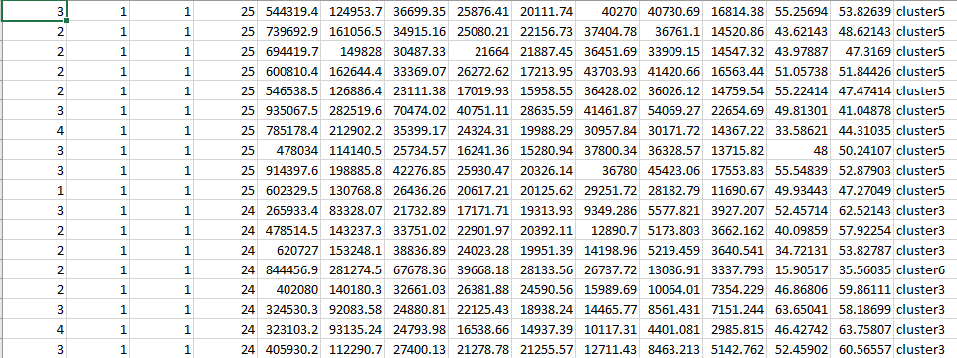

*Figure 21.* Partial screenshot of the final dataset with added cluster attribute.

*See Appendix I for the full table*

## Ensemble Machine Learning

In this machine learning method, bagging and boosting were utilized, namely Bagging via Random Forest, Bagging via Decision Trees and Boosting via Adaboost. The hyperparameters for the trees ranged from 50 to 100, with intervals of 10, with the resulting mean accuracy recorded from the input hyperparameter.

### Bagging via Random Forest

After this, the study performed Bagging via Random Forest on the finalized dataset with the cluster attribute while iteratively recording results each time a new number of trees(n_estimator) was set. Before this machine learning was performed however, an installation of libraries was required for the study to be able to perform machine learning with Python on the dataset.

Using the command prompt, ‘py -3.9 -m pip install -U scikit-learn’ was first typed to install libraries for ensemble machine learning to allow import of Classifiers such as the RandomForestClassifier for the Bagging via Random Forest, and the BaggingClassifier as well as the DecisionTreeClassifier for Bagging via Decision Trees, and the AdaBoostClassifier for Boosting via Adaboost. Next, ‘py -3.9 -m pip install -U pandas’ was used to allow for reading of ‘.csv’ files in Python. These packages were then imported in separate files depending on the machine learning process to be implemented in the file.

Bagging via Random Forest was performed by first importing libraries that allowed reading of ‘.csv’ files as well as the RandomForestClassifier. Following this, the path to the finalized dataset was then set in the code along with setting up the headernames of the dataset. The path to the dataset along with the predefined header names were then assigned in an array before setting up the number of trees which the study initially set at 50 trees before adding 10 as an interval per iteration until 100 trees are set. (Brownlee, 2020)

Following are the results for Bagging with Number of trees ranging from 50 to 100, in intervals of 10. See Appendix K for the code snippet.

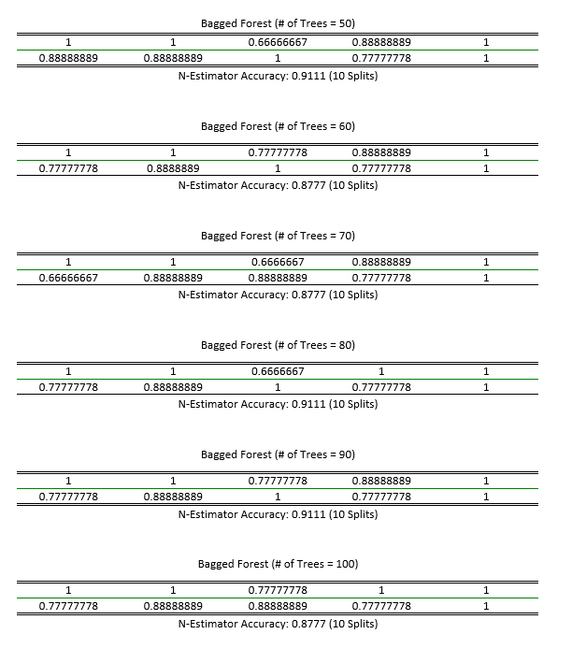

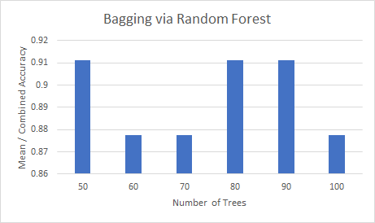

*Figure 22.* Bar Chart for Results of Bagging Via Random Forest

In this chart, the number of trees(hyperparameter) was initially set at 50, then increased by 10 after recording the resulting combined accuracy. Since the hyperparameter showed the highest combined accuracy which is 0.9111 at 50,80 and 90 number of trees, these hyperparameters will be noted and considered as a set number of trees for when a new EEG dataset will be used to predict its cluster attributes.

### Bagging via Decision Trees

After recording the results of Bagging via Random Forest, the study proceeded with Bagging via Decision Trees. It required the BaggingClassifier as well as the DecisionTreeClassifier, which required to be imported before use. After doing so, the path and header names were set in an array, before setting the number of trees. The number of trees were initially set at 50. The study then iteratively recorded results while adding 10 more after recording the results as an interval. Following are the results for each recorded result. See Appendix L for the code snippet.

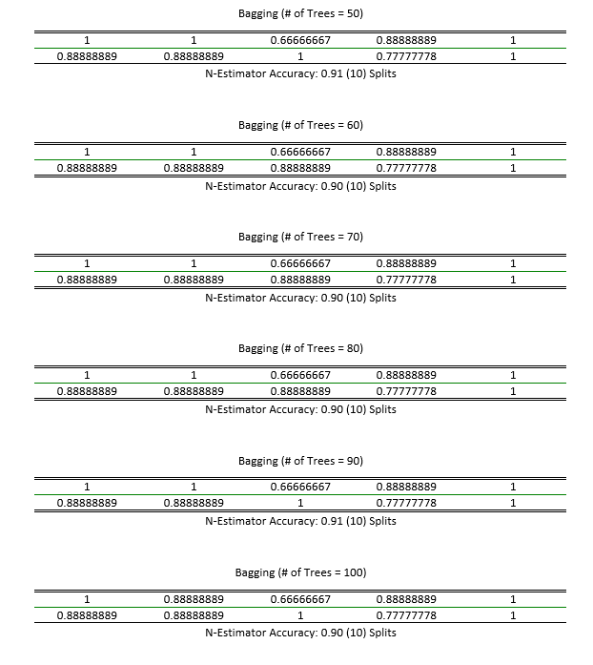

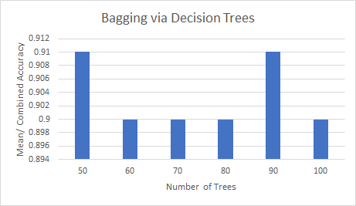

*Figure 23.* Bar Chart for Results of Bagging Via Decision Trees

In this chart, the hyperparameter was initially set at 50, then increased by 10 after recording the resulting combined accuracy. The highest combined accuracy seen at 50 and 90 number of trees is 0.91, which is lower than the accuracy seen in Bagging via Random Forest (0.9111) at 50, 80 and 90 number of trees. Thus, it can be inferred that Bagging via Random Forest is slightly better for this finalized dataset for EEG as it is more accurate.

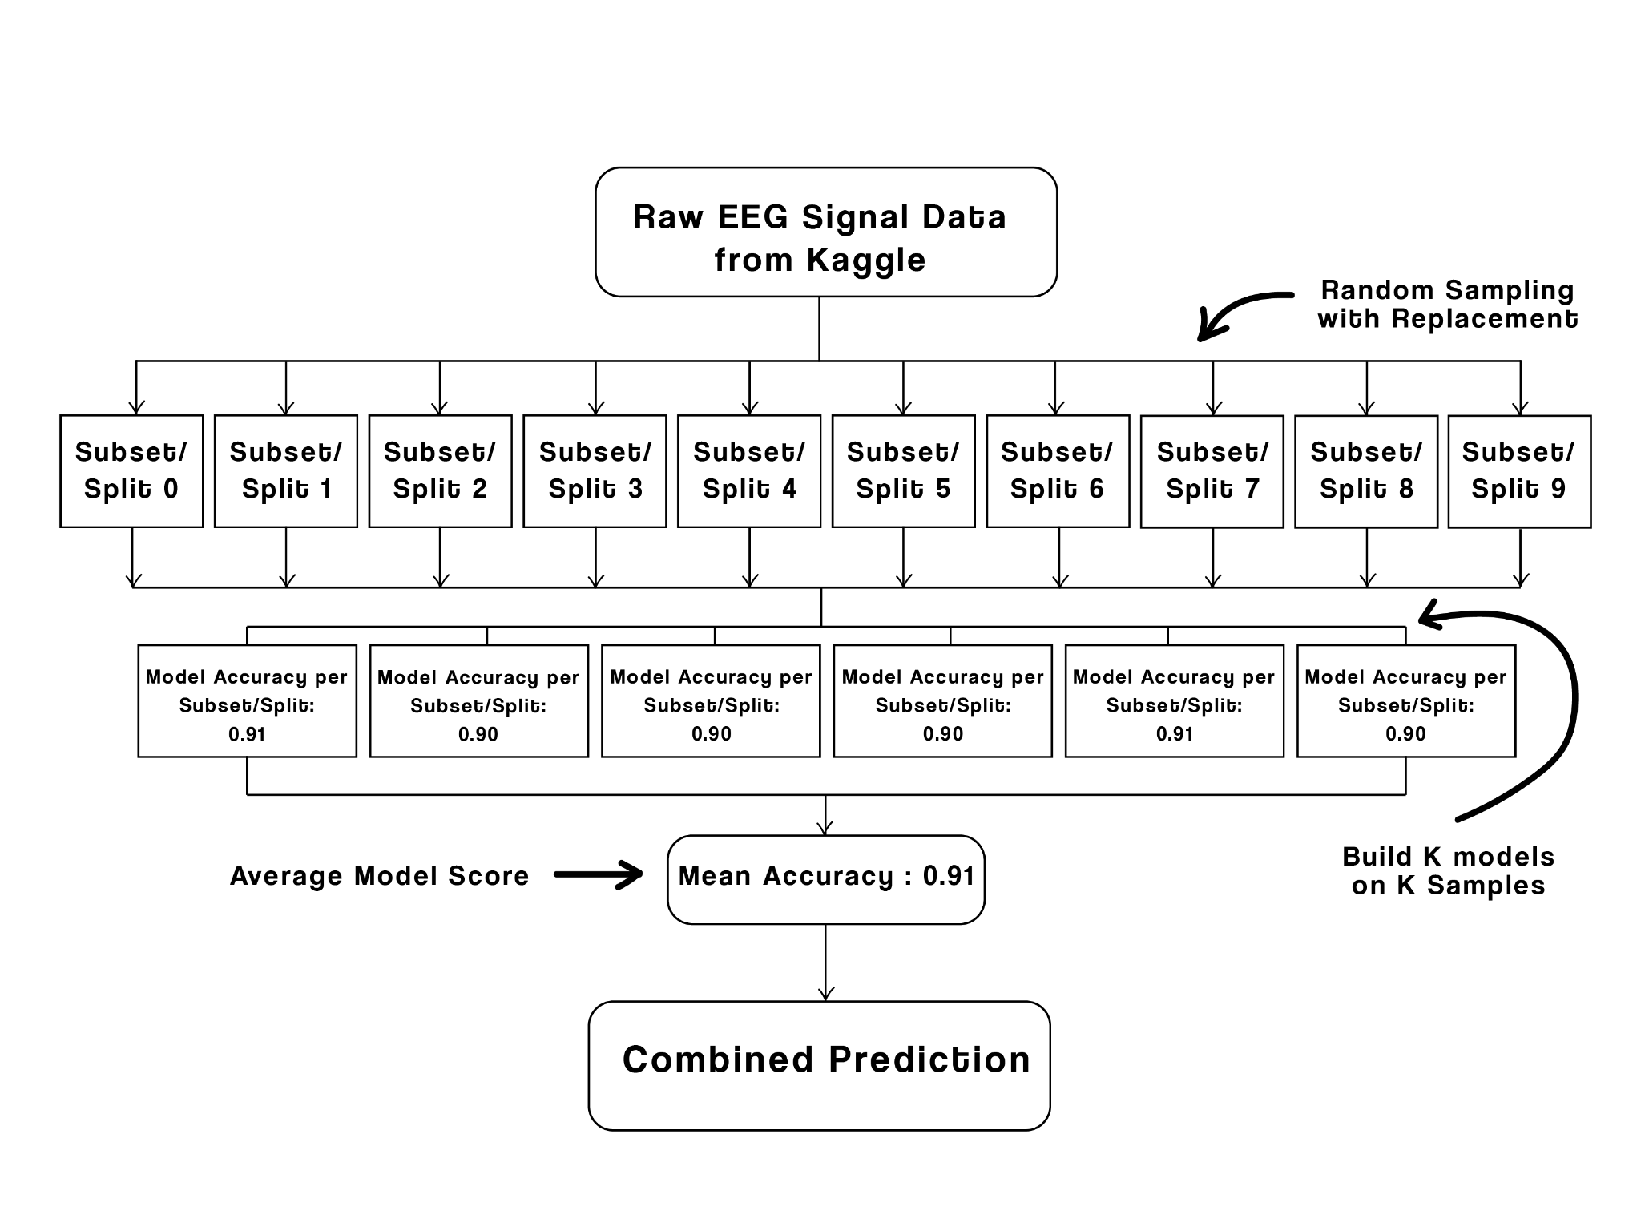

*Figure 24.* Visual Representation of Bagging to Combined Prediction.

In this visual representation of bagging the Raw EEG Signal Data from Kaggle was then used for random sampling with replacement. This random sampling with replacement was made through subsets and splits all throughout the given data, after trials we were able to build K-models based on K- samples which then became the model accuracy per subset / split. We chose the average model score among the rest of the model accuracy for there were identical values per model accuracy. We chose the highest one among the rest and it proceeded to the combined prediction.

### Boosting via Adaboost

Finally, boosting via Adaboost was applied on the dataset. This process required the AdaBoostClassifier to be imported before use. Data paths were then set along with the headernames in an array. The number of trees were then set starting at 50, and results were iteratively recorded before increasing the number of trees by 10 in each interval. Following are the results for Boosting with Adaboost with the number of trees ranging from 50 to 100, with intervals of 10. See Appendix M for the code Snippet.

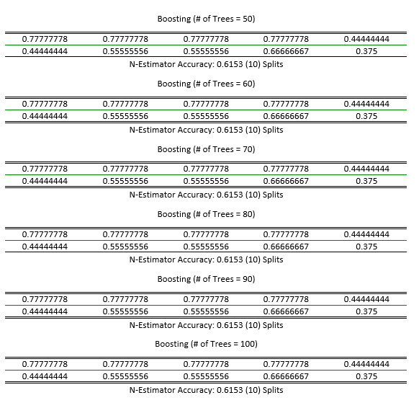

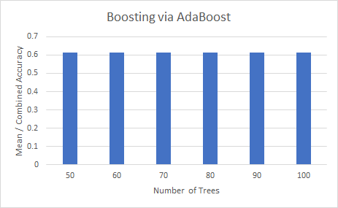

*Figure 25.* Bar Chart for Boosting Via AdaBoost

In this chart, it can be seen that Boosting via AdaBoost has lower accuracy on all set Number of Trees compared to both Bagging via RandomForest and Bagging via DecisionTrees. It can then be inferred that Bagging is better than Boosting in general, for this finalized dataset. However, what stands out is that accuracy remains stable throughout the changing of the hyperparameter, which cannot be said for Bagging via RandomForest and via DecisionTrees.

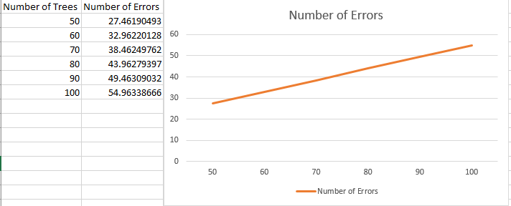

*Figure 26.* Statistical Chart for Number of Errors.

In this graph, the estimation error computation steadily increased as the n_estimator (number of trees) also increased, but did not contain any spikes which pertains to the stability of Boosting via Adaboost for this dataset.

After applying the above machine learning methods, the study found to have the highest N-Estimator Accuracy was Bagging via Random Forest with number of trees = 50 and 90 at an accuracy of 0.9111.

Following this, a new EEG Dataset from Kaggle as seen in Appendix O was then used to predict which cluster it belonged to using the code for Bagging via Random Forest with the number of trees set to 50. The code used for Bagging via Random Forest was then modified accordingly to predict which cluster’s attributes might be similar on the model. See Appendix N for the code Snippet.

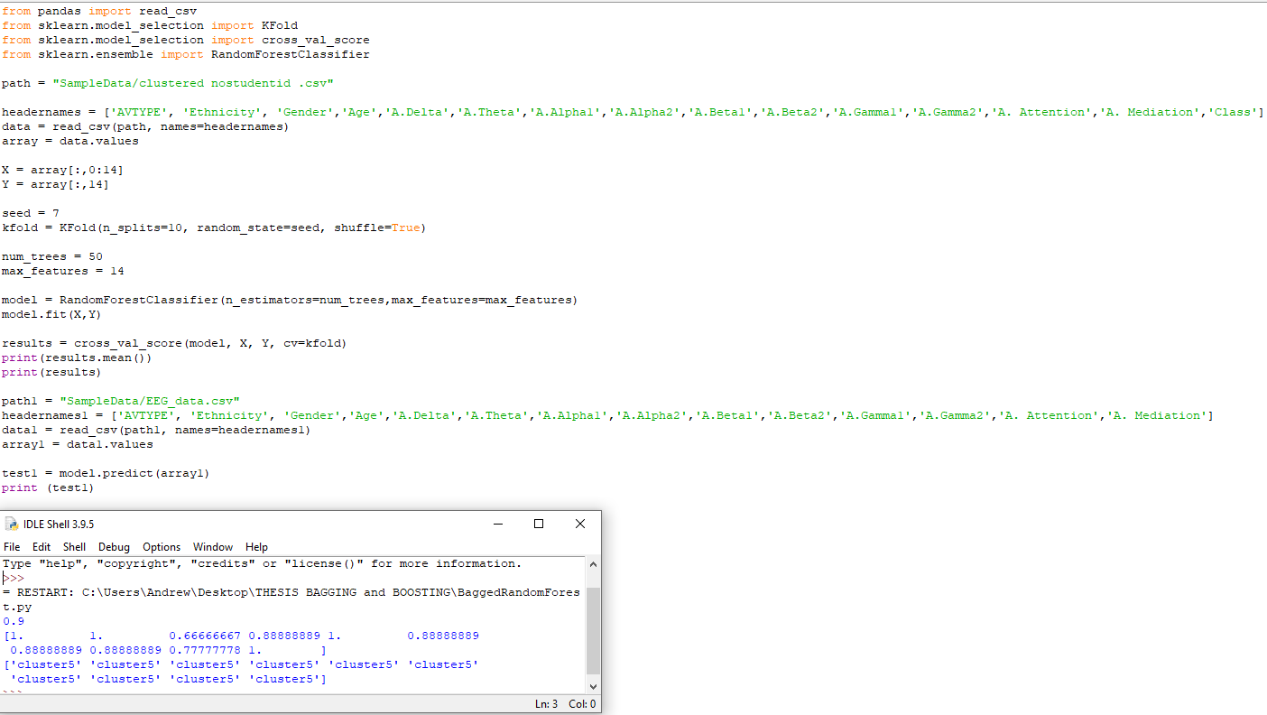

# *Figure 27.* Sample Screenshot of Actual Prediction.

# 

# Figure 28. Screenshot of Prediction Results.

# 

# **Conclusions**

The first objective was to acquire the pre-recorded EEG Signal dataset from Kaggle. This dataset was then subjected to preprocessing by checking of values, formatting, combining, and other forms of cleansing. The structured dataset was then transformed and pre-processed using data framing the time points of the recorded brain waves of each corresponding student.

The second objective was to identify attention pattern groups using Clustering techniques. Elbow methodology was used to determine the optimal number of clusters in k-means clustering. The elbow method then plotted the value of the cost function produced by different values of k, which was then determined to be 6. After k = 6 was found, clustering was then performed. With this methodology being done, dataset pattern labeling was then performed. This was the process of identifying raw data and adding one or more meaningful and informative labels to provide context so that a model can learn from it. Of the resulting 6 clusters which were cluster 0 to 5, it was found that having higher average brain waves can have a polarizing effect on attention. This was clear with cluster 5, who had the highest average brain waves, but the lowest average attention among the clusters. With cluster 0 however, despite having the highest average attention and mediation which translated to relaxation and calmness, contained all of the lowest average brainwaves. Of the AVTypes determined in the clusters, only cluster 3, which was the youngest of the clusters, had the AVType of exactly 2, the lowest number of datapoints, and highest average alpha2 and beta2 brain waves which translated to faster brain activity. This cluster also had the lowest gamma 2 average brain waves which indicated having the least familiarity with the viewed audiovisual materials (Matta, Venkitasubramanian, 2014).

The third objective that was done developed an attention pattern predictive model via Ensemble Machine Learning. Here, multiple learners were trained and combined to solve a problem. This process ensured that the integrated generalization capability is much more robust than that of a single learner. Two methods of Ensemble Machine Learning were then utilized, namely, bagging and boosting. Bagging via Random Forest was utilized and created the highest accuracy compared to other methods, peaking at 0.9111 accuracy when the hyperparameter was set to 50, 80 and 90 respectively. Bagging via Machine Learning was then utilized, with accuracy peaking at 0.91 when hyperparameters were set at 50 and 90 trees, which was slightly less than the peaks of mean accuracy from Bagging via Random Forest. Boosting via Adaboost on the other hand, created the lowest accuracy for this dataset, but was the most stable on different hyperparameters, with the number of trees increasing from 50 to 100 in intervals of 10, along with an increasing number of total errors. The increasing number of errors however, was graphed and found to be consistent, showing the stability of Boosting via Adaboost for this dataset.

The fourth and last objectives were to test the Ensemble-based model using an acquired EEG dataset from Kaggle. This acquired dataset was subjected to preprocessing to arrange the data to have the same format as the previous dataset. Using the model with the highest accuracy, which was Bagging via Random Forest at hyperparameters set to 50,80 and 90, the preprocessed dataset was then input for prediction using the previously created model, of which the study's model was able to do so, assigning the dataset's cluster attributes at cluster 5 of the model. Using this model, which allowed new datasets to have attributed clusters based on the study's created model, will allow for easier predictions on the states of brainwaves and brain activity for future datasets using EEG. This will also help further studies in understanding brain activities as well as allow educators to tailor their audiovisuals best for the betterment of e-learning.

# **Recommendations**

This study was able to identify some patterns with the pre-recorded brain waves done by Neurosky’s Mindset, along with other trivialized attributes such as gender, age, and ethnicity. It is recommended to collect more datasets that contain a wider variety of ethnicities and a wider range of ages to broaden the scope of clusters or discover new ones.

In this study, the brainwaves used for clustering were averaged in the scope of one video, instead of using all the detected frequencies in the timeframe of the video. The peaks and lows of these detected frequencies can be further considered for clustering along with a probability of discovering new patterns for detected brain waves.

The study also has its categorization of audiovisual types which depended on the content of the videos. Due to the amount of videos used in this study, patterns were hardly recognized from brainwaves in different videos in different clusters. This study then recommends that more audiovisual types should be used to discover a recognizable pattern for other models.

In the study of Nascimento et al. (2020), a dynamic model was created from sparse time series models to estimate contemporaneous and ongoing brain activity. It was concluded that doing so was found useful for describing intervention-relocated changes in brain connectivity. They were also found useful in assessing the role of estimating the brain network structure and describing its causal relationship. It is thus recommended to develop a dynamic model to further analyze the complex outcome measure (EEG).

Finally, since this study is mostly for the benefit of understanding attention patterns for E-Learning Audiovisual aids with ensemble machine learning, it is recommended to try creating new models from other datasets in order to compare the most effective machine learning method in order to have a more accurate model, leading to more accurate predictions of clusters.

**References**

Akram, S., & Sufiana, K.M. (2012*). Use of audio visual aids for effective teaching of biology at secondary schools level*. Elixir Leadership management. doi: 50. 10597-10605.

Alwedaie, S.A., Khabbaz, H.A., Hadi, S.R., & Al-Hakim, R. (2018). *EEG-based Analysis through Virtual Reality Environment*. DOI: 10.4172/2155-6210.100024

Ashaver, D., & Igyuve S., (2013). *The Use of Audio-Visual Materials in the Teaching and Learning Processes in Colleges of Education in Benue State-Nigeria*. Retrieved from:  
<http://iosrjournals.org/iosr-jrme/papers/Vol-1%20Issue-6/G0164455.pdf>

Arsyad, A. (2014). *Media Education*. American Journal of Education Research, 2020, Vol. 8 No. 1, 24-28. doi: 10.12691/education-8-1-4.

Asanza, V., Ochoa, K., Sacarelo, C., López, C., Loayza, F., & Vaca, C., & Pelaez, C. (2016). *Clustering of EEG occipital signals using k-means*, 1-5. doi: 10.1109/ETCM.2016.7750874.

Asmani, J.M. (2011*). Effective Tips on Using ICT In Education*. Diva Press, Yogyakarta, p. 221.

Atyabi, A., Shic, F., & Naples, A. (2016). *Mixture of autoregressive modeling orders and its implication on single trial EEG classification. Expert systems with applications*, *65*, 164–180. https://doi.org/10.1016/j.eswa.2016.08.044

Babiker, A., Faye, I., Mumtaz, W. Malik S.A., & Sato, H. (2019). *EEG in classroom: EMD features to detect situational interest of students during learning*. Multimed Tools Appl 78, 16261–16281 (2019). <https://doi.org/10.1007/s11042-018-7016-z>

Beebe, D.W., Rose, D., Amin, R. (2010). *Attention, learning, and arousal of experimentally sleep-restricted adolescents in a simulated classroom*. J Adolesc Health. 2010 Nov;47(5):523-5. doi: 10.1016/j.jadohealth.2010.03.005. Epub 2010 Apr 28. PMID: 20970088; PMCID: PMC2963797.

Belton, T., & Priyadharshini, E. (2007). *Boredom and schooling: A cross-disciplinary exploration. Cambridge Journal of Education*. 37. 579-595. 10.1080/03057640701706227.

Brownlee, J. (2020). Develop a Bagging Ensemble with Python. Retrieved from: https://machinelearningmastery.com/bagging-ensemble-with-python/

Brucher, M. (2011). *Scikit-learn: Machine Learning in Python*. Retrieved from: https://www.jmlr.org/papers/volume12/pedregosa11a/pedregosa11a.pdf

Cavanagh, J.F., Napolitano, A., Wu, C., & Mueen A. (2017). *The Patient Repository for EEG Data + Computational Tools (PRED+CT)*. Front Neuroinform. 2017;11:67. Published 2017 Nov 21. doi:10.3389/fninf.2017.00067   
Retrieved from: https://www.ncbi.nlm.nih.gov/pmc/articles/PMC5702317/

Chary, P.D., & Singh, R.P., (2020) *Review on Advanced Machine Learning Model: Scikit-Learn* - Retrieved from:  
<https://www.researchgate.net/publication/344285242_Review_on_Advanced_Machine_Learning_Model_Scikit-Learn>

Chauhan, J., & Goel, A. (2015). *An Analysis of Video Lecture in MOOC*. Retrieved from: <https://www.researchgate.net/publication/322918575_An_Analysis_of_Video_Lecture_in_MOOC>

# Chengsheng, T., Huacheng, L., & Bing, X. (2017). *AdaBoost typical Algorithm and its application research*. MATEC Web of Conferences. 139. 00222. 10.1051/matecconf/201713900222.

Chouhan, T., Panse, A., Smitha, K.G. & Vinod, A.P. (2015). *A Comparative Study on the Effect of Audio and Visual Stimuli for Enhancing Attention and Memory in Brain Computer Interface System. 10.1109/SMC.2015.539*. Retrieved from: https://www.researchgate.net/publication/283494651_A_Comparative_Study_on_the_Effect_of_Audio_and_Visual_Stimuli_for_Enhancing_Attention_and_Memory_in_Brain_Computer_Interface_System

Chuang, J., Merrill, N., & Maillart, T. (2015). *Synchronized Brainwave Recordings from a Group Presented with a Common Audio-Visual Stimulus*. Retrieved from: https://www.kaggle.com/datasets/berkeley-biosense/synchronized-brainwave-dataset

Clawson, J. (2008). Audiovisual Tools and Techniques. Darden Case: Pedagogy (Topic). Retrieved from: https://www.researchgate.net/publication/228144676_Audiovisual_Tools_and_Techniques/citation/download

Collins, A., & Halverson, R. (2009). *Rethinking education in the age of technology: the digital revolution and the schools*. Retrieved from: https://www.researchgate.net/publication/264869053_Rethinking_education_in_the_age_of_technology_the_digital_revolution_and_the_schools

Crowley, K., Sliney, A., Pitt, I., & Murphy, D., (2010*). Evaluating a Brain-Computer Interface to Categorise Human Emotional Response*. Proceedings - 10th IEEE International Conference on Advanced Learning Technologies, ICALT 2010. 276 - 278. 10.1109/ICALT.2010.81.

Corsi-Cabrera, M., Ramos-Loyo, J., Guevara, M., Arce, C., & Gutierrez, S. (1993). *Gender Differences in the EEG During Cognitive Activity*. International Journal of Neuroscience - INT J NEUROSCI. 72. 257-264. 10.3109/00207459309024114.

Corso, J. (2008). Boosting and Adaboost. Retrieved from: https://cse.buffalo.edu/~jcorso/t/cse555/files/lecture_boosting.pdf

Dabbura, I. (2018) K-means Clustering: *Algorithm, Applications, Evaluation Methods and Drawbacks*. Retrieved from: <https://towardsdatascience.com/k-means-clustering-algorithm-applications-evaluation-methods-and-drawbacks-aa03e644b48a>

Dan, N., Shuo, W., & Guocheng, L. (2020). *The EEG-Based Attention Analysis in Multimedia m-Learning, Computational and Mathematical Methods in Medicine*, vol. 2020, Article ID 4837291, 10 pages, 2020. https://doi.org/10.1155/2020/4837291

El-Seoud, S., Taj-Eddin, I., Seddiek, N., Mohamed, M., & Nosseir, A. (2014). *E-Learning and Students' Motivation: A Research Study on the Effect of E-Learning on Higher Education*. International Journal of Emerging Technologies in Learning (iJET). Vol. 9. 20-26. 10.3991/ijet.v9i4.3465.

Jukic, S., Saracevic, M., Subasi, A., & Kevric, J. (2020). *Comparison of Ensemble Machine Learning Methods for Automated Classification of Focal and Non-Focal Epileptic EEG Signals*. Retrieved from: https://www.mdpi.com/2227-7390/8/9/1481

Kim, J. & Wang, Z. (2018). *Sampling Techniques for Big Data Analysis*. International Statistical Review. 87. 10.1111/insr.12290.

Kim S., & Park W. (2019). *Use of Electroencephalography (EEG) In Academic Achievement Assessment. International Journal of Scientific & Technology Research 8,* 11. Retrieved from: <http://www.ijstr.org/final-print/nov2019/Use-Of-Electroencephalography-eeg-In-Academic-Achievement-Assessment.pdf>

Ko, L., Komarov, O., Hairston, W.D., Jung, T., & Lin C., (2017). *Sustained Attention in Real Classroom Settings: An EEG Study. Frontiers in Human Neuroscience, 11,* 388. https://doi.org/10.3389/fnhum.2017.00388

Kowald, D., Traub, M., Theiler, D., Gursch, H., Lindstaedt, S., Kern, R., & Lex, E. (2019). *Using the Open Kaggle Dataset to evaluate Tripartite Recommendations in Data markets*. Retrieved from: https://www.researchgate.net/publication/335134894_Using_the_Open_Meta_Kaggle_Dataset_to_Evaluate_Tripartite_Recommendations_in_Data_Markets

Kumar, A. (2020). *The Ultimate Guide to AdaBoost Algorithm.*Retrieved from: https://www.mygreatlearning.com/blog/adaboost-algorithm/

Kumar e, P., Kenikar, S., & Chandra, A. (2019). *Analysis of Different EEG Data Sets Extracted From Brain Using ICA, Volume 3*. 528. Retrieved from: https://www.researchgate.net/publication/338230938_Analysis_of_Different_EEG_Data_Sets_Extracted_From_Brain_Using_ICA

Lalian, N.O. (2018). *The Effects of Using Video Media in Mathematics Learning on Students’ Cognitive and Affective Aspects*. Department of Educational Technology, State University of Jakarta, Jalan Rawamangun Muka, Jakarta 13220, Indonesia

Langner, R., & Eickhoff, S. (2013). *Sustaining Attention to Simple Tasks: A Meta-Analytic Review of the Neural Mechanisms of Vigilant Attention*. Psychological bulletin. 139. 870-900. 10.1037/a0030694.

Li, H. & Masters, J. (2009*). Editorial: E-learning and Knowledge Management in the Early Years: Where Are We and Where Should We Go*. Knowledge Management &   
E-Learning : an International Journal. 1.

Liu, N. H., Chiang, C. Y., & Chu, H. C. (2013). *Recognizing the degree of human attention using EEG signals from mobile sensors.* *Sensors (Basel, Switzerland)*, *13*(8), 10273–10286. <https://doi.org/10.3390/s130810273>

Mahilraj, J., Samuel, M., & Gure, A.T. (2016). *Chaos Genetic Algorithm and Adaboost Algorithm for Clustering the Data*. Retrieved from: https://www.researchgate.net/publication/330485851_Chaos_Genetic_Algorithm_and_Adaboost_Algorithm_for_Clustering_the_Data

Mathew, N., & Alidmat, A. (2013). *A Study on the Usefulness of Audio-Visual Aids in EFL Classroom: Implications for Effective Instruction.* International Journal of Higher Education. 2. doi: 10.5430/ijhe.v2n2p86.

Matta, P. & Venkitasubramanian, V. (2014). *NeuroClick:Analyzing Brainwave Signals to Understand What Clicks*. Retrieved from: https://www.ischool.berkeley.edu/projects/2014/neuroclick-analyzing-brainwave-signals-understand-what-clicks

Nascimento, D.C., Pinto-Orellana, M.A., Leite, J.P., Edwards, D.J., Louzada, F., & Santos, T.E.G. (2020). *BrainWave Nets: Are Sparse Dynamic Models Susceptible to Brain Manipulation Experimentation?* doi: 10.3389/fnsys.2020.527757. PMID: 33324178; PMCID: PMC7726475.

Nassim, B. (2019). *Parameterization Methods and Autoregressive Model*. Retrieved from: <https://www.intechopen.com/books/smart-healthcare/parameterization-methods-and-autoregressive-model>

Noachtar, S., Binnie, C., Ebersole, J., Mauguiere, F., Sakamoto, A., & Westmoreland, B. (1999). *A glossary of terms most commonly used by clinical electroencephalographers and proposal for the report form for the EEG findings.* *Klinische Neurophysiologie*, *35*(1), 5-21. Retrieved from: https://pubmed.ncbi.nlm.nih.gov/10590974/

Peters R. (2006). *Ageing and the brain. Postgraduate medical journal*, 82(964), 84–88. Retrieved from: <https://doi.org/10.1136/pgmj.2005.036665>

Pujol, J., Blanco-Hinojo, L., Martínez-Vilavella, G., Canu-Martín, L., Pujol, A., Pérez-Sola, V., & Deus, J. (2019). *Brain activity during traditional textbook and audiovisual-3D learning.* *Brain and behavior*, *9*(10), e01427. <https://doi.org/10.1002/brb3.1427>

Rasul, S., Bukhsh, Q.,& Batool, S. (2011). *A study to analyze the effectiveness of audio visual aids in teaching learning process at university level*, Procedia - Social and Behavioral Sciences. 28. 78–81. 10.1016/j.sbspro.2011.11.016.

Rustam, S., Wu, T., & Huang, Y., (2017*) Enhancing learning performance, attention, and meditation using a speech-to-text recognition application: evidence from multiple data sources*, Interactive Learning Environments, 25:2, 249-261, DOI: [10.1080/10494820.2016.1276079](https://doi.org/10.1080/10494820.2016.1276079)

Schapire, R.E. (1989). *The strength of weak learnability*. 30th Annual Symposium on Foundations of Computer Science, Research Triangle Park, NC, USA, 1989, pp. 28-33, doi: 10.1109/SFCS.1989.63451.

Schapire, R., & Yoram, S. 1999. *Improved Boosting Algorithms Using Confidence-rated Predictions*. Mach. Learn. 37, 3 (Dec. 1999), 297–336. DOI: <https://doi.org/10.1023/A:1007614523901>

Sethi, C., Dabas, H., Dua, C., Dalawat, M., & Sethia, D. (2018). *EEG-Based Attention Feedback to Improve Focus in E-Learning*. 321-326. 10.1145/3297156.3297157. Retrieved from: https://www.researchgate.net/publication/331420737_EEG-Based_Attention_Feedback_to_Improve_Focus_in_E-Learning

Siuly, Li, Y. & Wen, P. (2009). *Classification of EEG Signals Using Sampling Techniques and Least Square Support Vector Machines*, 375-382. doi: 10.1007/978-3-642-02962-2_47.

Soni, A. (2020). *Diabetes Mellitus Prediction Using Ensemble Machine Learning Techniques*. SSRN Electronic Journal. 10.2139/ssrn.3642877.

Viswanathan, V., Bharadwaj, H. M., & Shinn-Cunningham, B. G. (2019). *Electroencephalographic Signatures of the Neural Representation of Speech during Selective Attention*. eNeuro, *6*(5), ENEURO.0057-19.2019. <https://doi.org/10.1523/ENEURO.0057-19.2019>

Wilson, J. (2013). *Capturing students’ attention: An empirical study*. Journal of the Scholarship of Teaching and Learning. 13. 1-20.

Zhu, G., Li, Y., Wen, P.., Wang, S., & Zhong, N. (2013) *Unsupervised Classification of Epileptic EEG Signals with Multi Scale K-Means Algorithm. In: Imamura K., Usui S., Shirao T., Kasamatsu T., Schwabe L., Zhong N. (eds) Brain and Health Informatics. BHI 2013. Lecture Notes in Computer Science, vol 8211*. Springer, Cham. https://doi.org/10.1007/978-3-319-02753-1_16

# 

# **Appendices**

Appendix A



Audiovisual stimulus (AVType 2) where a virtual blackboard is accompanied by a voice as well as subtitles.

Appendix B

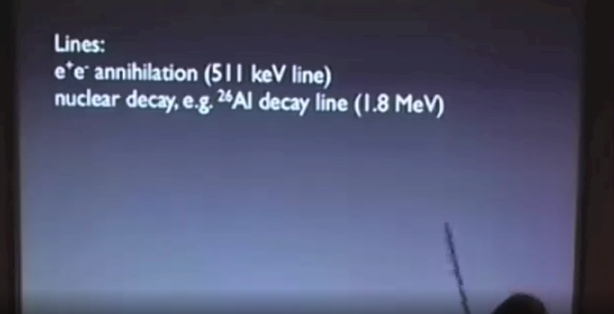

Powerpoint Presentation (AVType 4) where the use of media and tools is present.

Appendix C

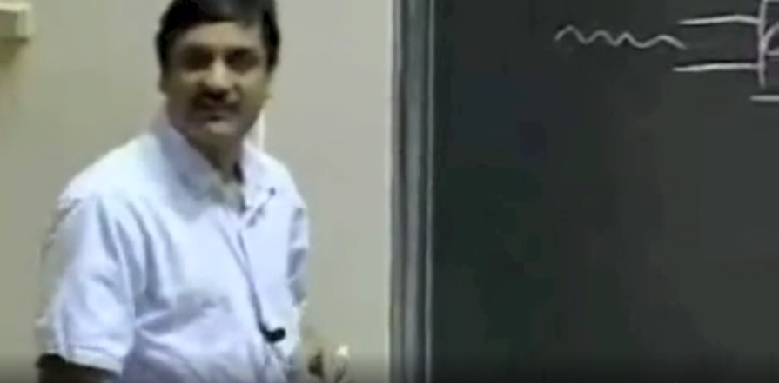

Video with only a teacher (AVType 1) discussing his lecture.

Appendix D

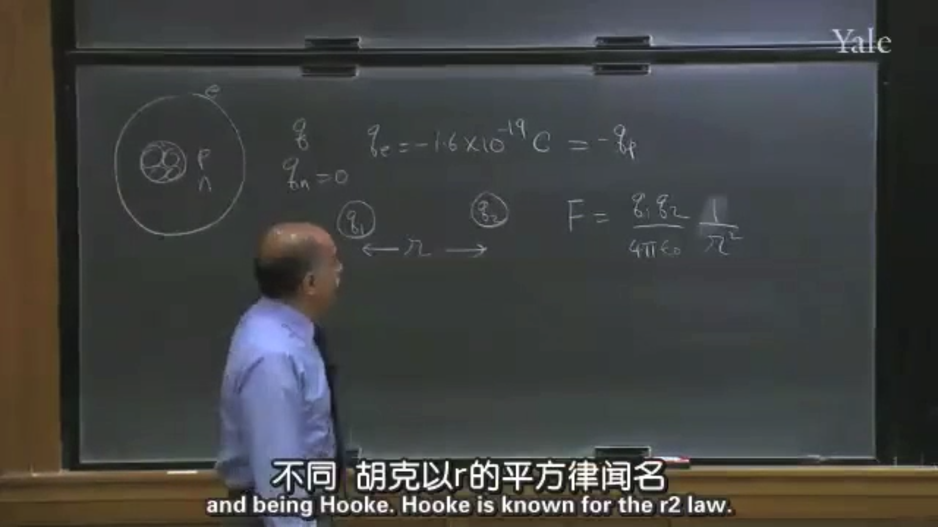

Screenshot from one of the audiovisual stimulus (AVType 3) used, where a professor explains what is written on his blackboard.

Appendix E

|  |  |  |  |
| --- | --- | --- | --- |
| Subject ID | Age | Ethnicity | Gender |
| 0 | 25 | Han Chinese | M |
| 1 | 24 | Han Chinese | M |
| 2 | 31 | English | F |
| 3 | 28 | Han Chinese | M |
| 4 | 24 | Bengali | M |
| 5 | 24 | Han Chinese | M |
| 6 | 24 | Han Chinese | M |
| 7 | 25 | Han Chinese | M |
| 8 | 25 | Han Chinese | M |
| 9 | 24 | Han Chinese | F |

Demographic Information of the subjects used for EEG readings

Appendix F

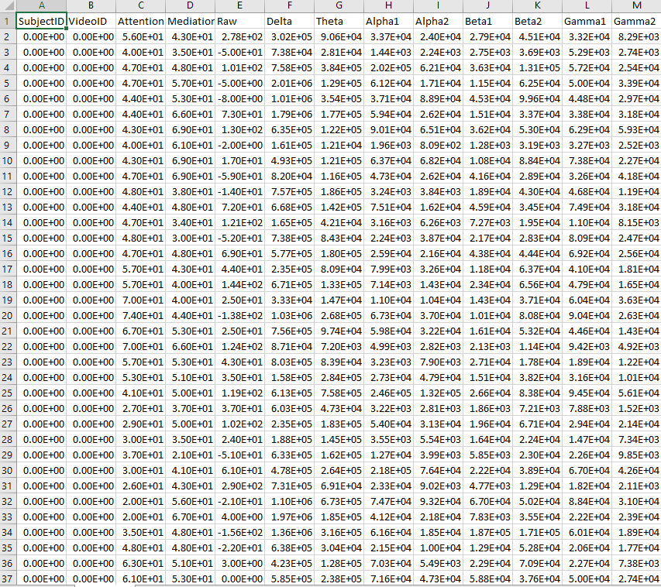

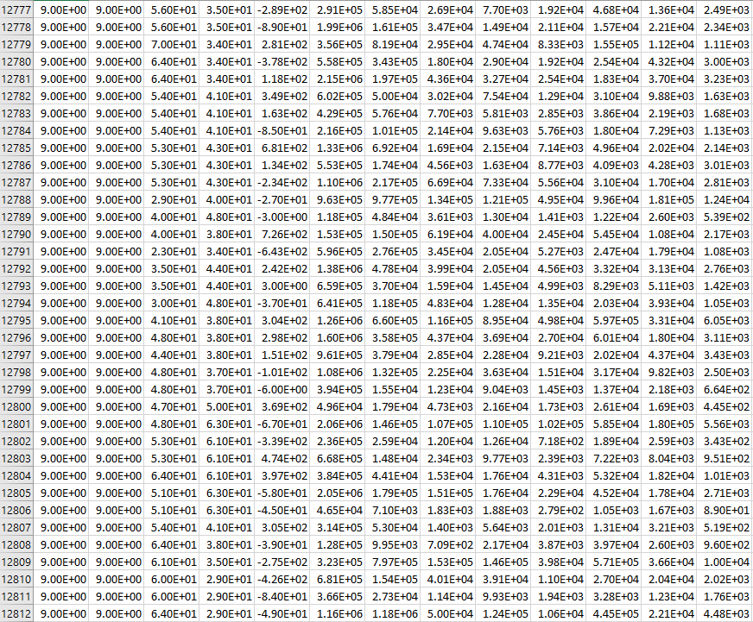

12000+ rows of EEG signal readings

Appendix G

Attribute Table of Dataset using K-Means where K = 6

|  |  |  |  |  |  |  |  |
| --- | --- | --- | --- | --- | --- | --- | --- |
| Attributes | Full Data | Cluster #0 | Cluster #1 | Cluster #2 | Cluster #3 | Cluster #4 | Cluster #5 |
| StudentID | 4.5 | 6 | 6 | 0.5 | 2 | 4 | 6.6667 |
| **AV Type** | 2.5056 | 2.5 | 2.7692 | 2.5 | 2 | 2.4444 | 2.5714 |
| **Ethnicity** | Han Chinese | English | Han Chinese | Han Chinese | Han Chinese | Han Chinese | Han Chinese |
| **Gender** | M | M | F | M | F | M | M |
| **Age** | 25.5281 | 31 | 26.7692 | 24.2143 | 24 | 24.9444 | 24.5 |
| **A.Delta** | 590513.4436 | 40514.5573 | 807680.6581 | 437846.6667 | 885717.4607 | 631032.233 | 908436.4808 |
| **A.Theta** | 159445.5028 | 19355.5755 | 222079.6725 | 123765.5075 | 165628.8669 | 150976.1955 | 280948.523 |
| **A.Alpha1** | 38593.6384 | 7802.8547 | 53948.6311 | 29041.8907 | 48629.5986 | 33380.7279 | 67833.5311 |
| **A.Alpha2** | 28155.8624 | 8212.9707 | 34840.7446 | 22085.8465 | 52048.8725 | 23107.8515 | 44583.8647 |
| **A.Beta1** | 20303.926 | 7979.9749 | 23534.2056 | 17934.0752 | 19144.3672 | 19775.9441 | 32022.6919 |
| **A.Beta2** | 24252.4378 | 8339.9904 | 24060.3957 | 15809.5104 | 55735.044 | 33761.4436 | 26964.2413 |
| **A.Gamma1** | 17006.5009 | 4581.5473 | 18672.3842 | 10207.9378 | 24724.8187 | 31477.0466 | 16018.8647 |
| **A.Gamma2** | 8289.297 | 3537.323 | 7554.392 | 6480.5887 | 3516.1382 | 16117.3232 | 7964.4268 |
| **A.Attention** | 46.3658 | 55.7293 | 43.9043 | 48.5774 | 43.2773 | 46.5804 | 38.5878 |
| **A.Mediation** | 53.0088 | 60.9399 | 50.4746 | 56.0502 | 52.4627 | 48.0101 | 50.2752 |

Appendix H

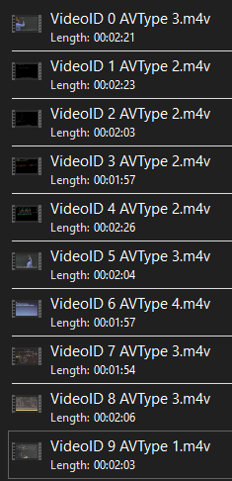

List of Videos with videoID with AVType

Appendix I

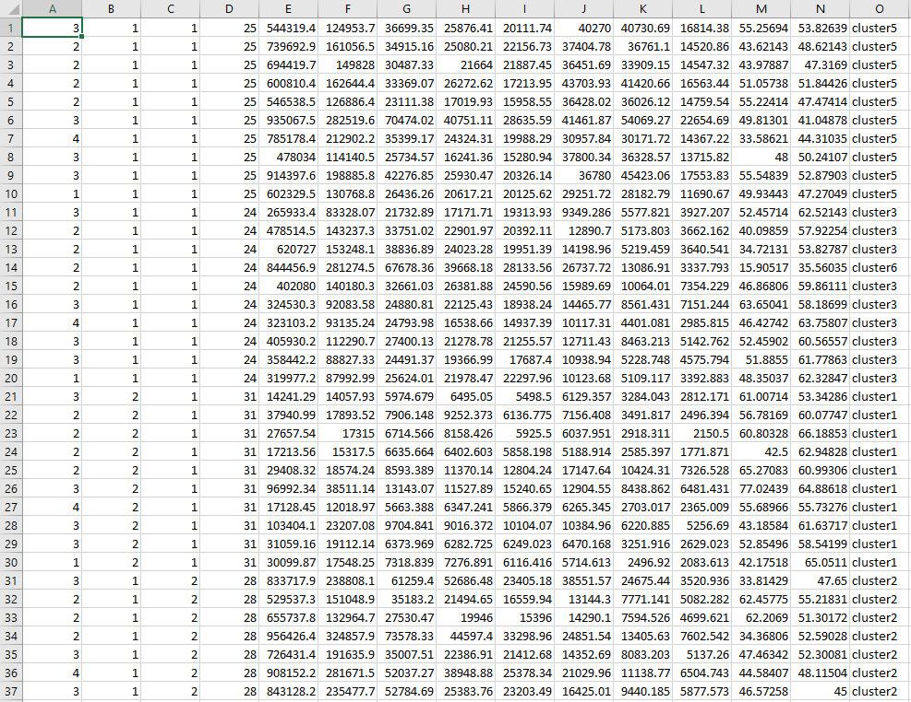

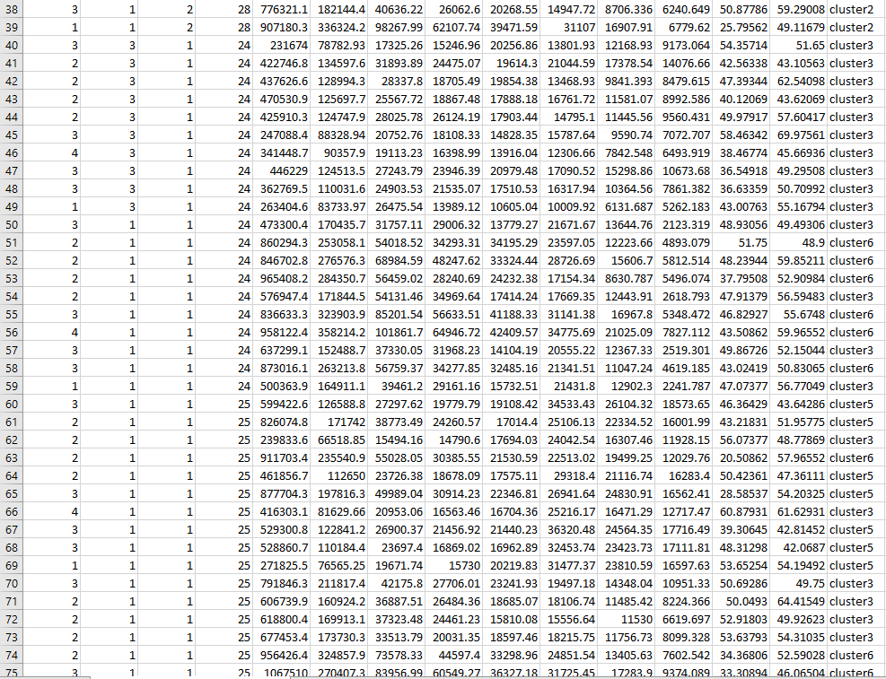

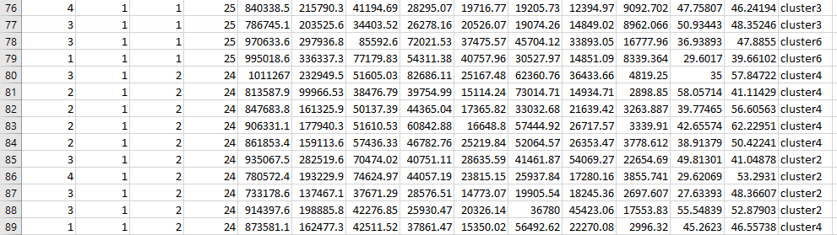

Final table from the final dataset

Appendix J

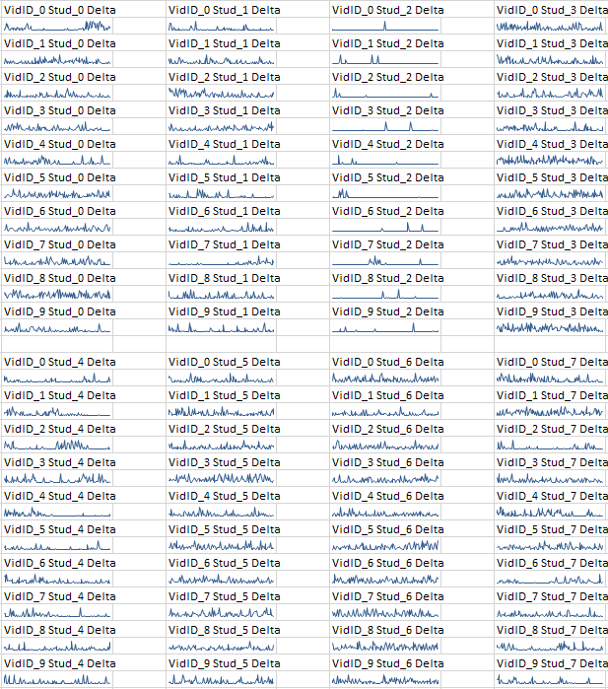

Table of visualized brainwaves of students

Appendix K

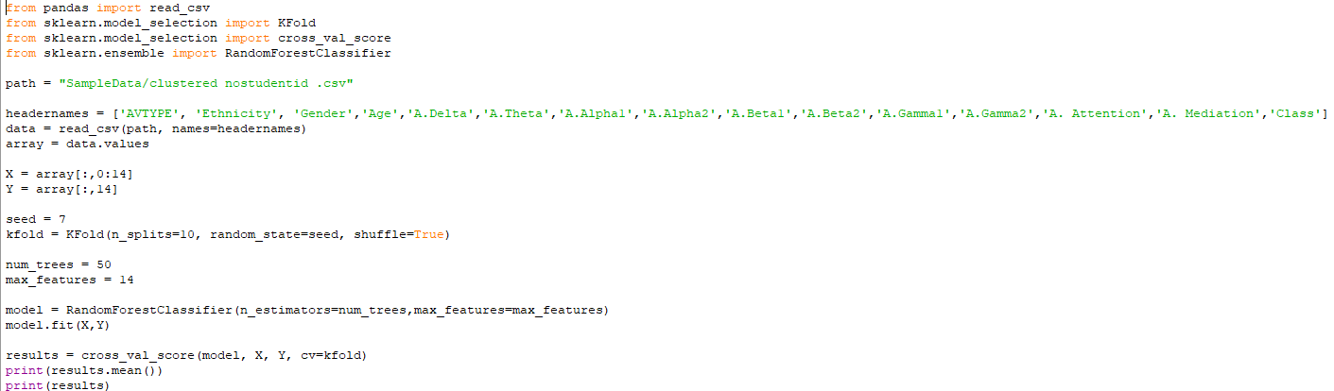

Snippet of Code for Bagging via Random Forest in Python

Appendix L  
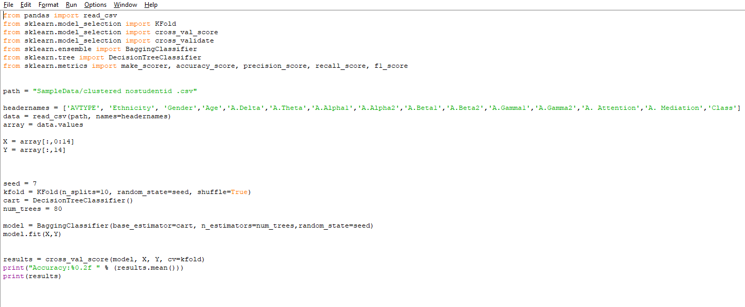

Snippet of Code for Bagging via Decision Trees in Python

Appendix M

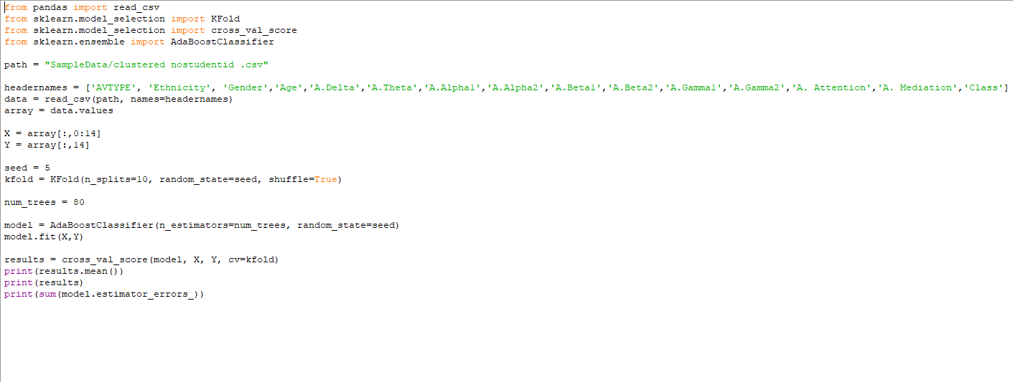

Snippet of Code for Bagging via Decision Trees in Python

Appendix N

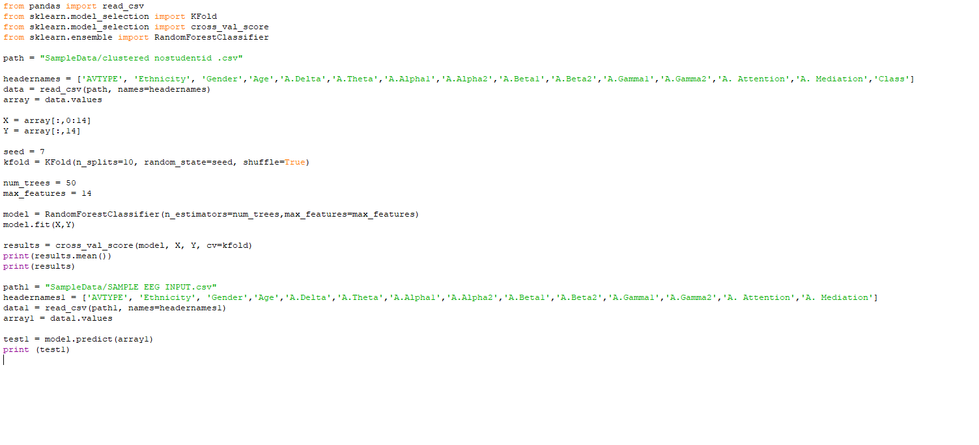

Code Snippet for Bagging via Random Forest with Model Prediction

Appendix O

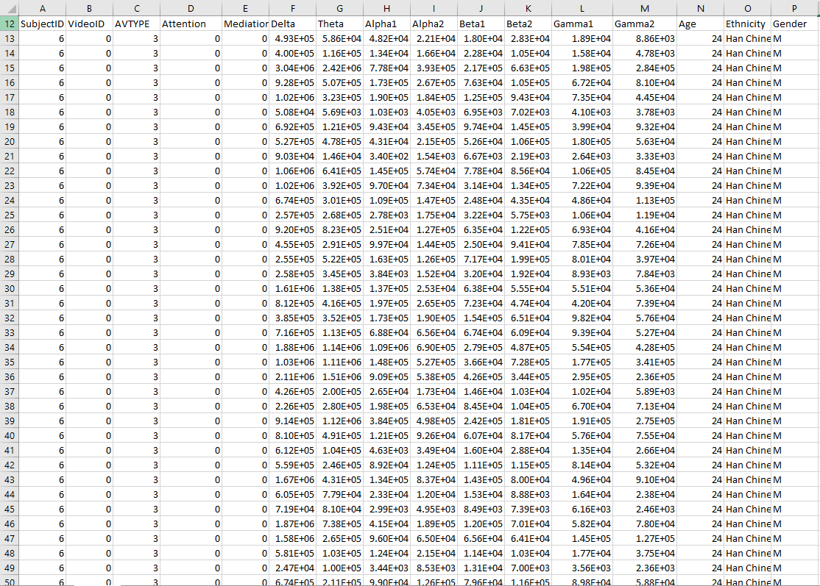

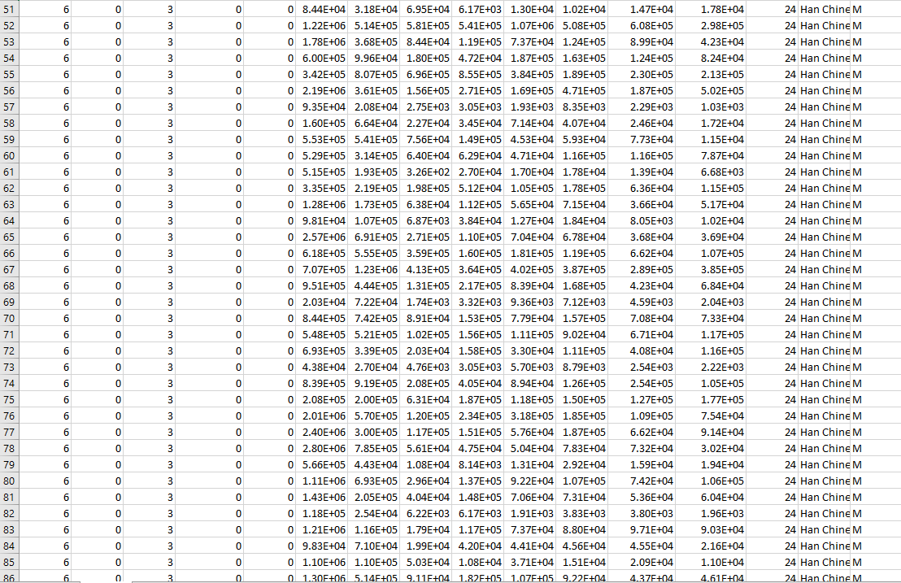

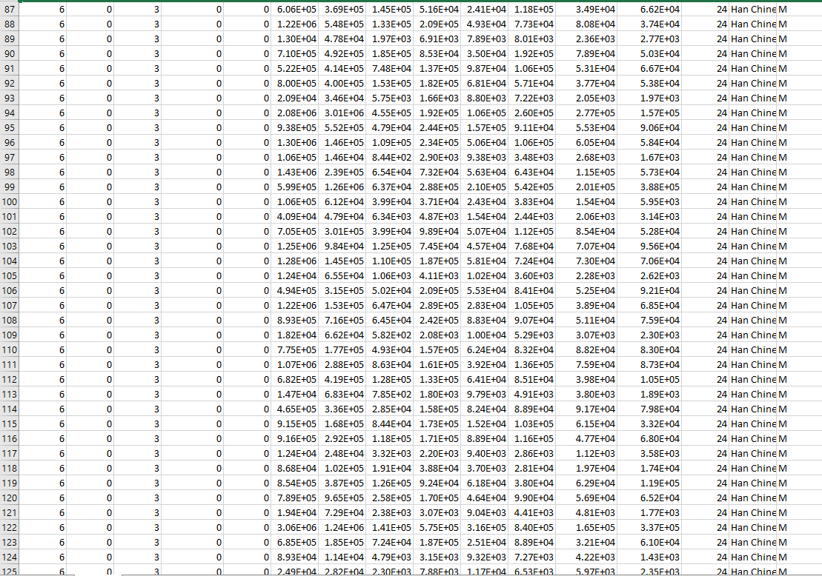

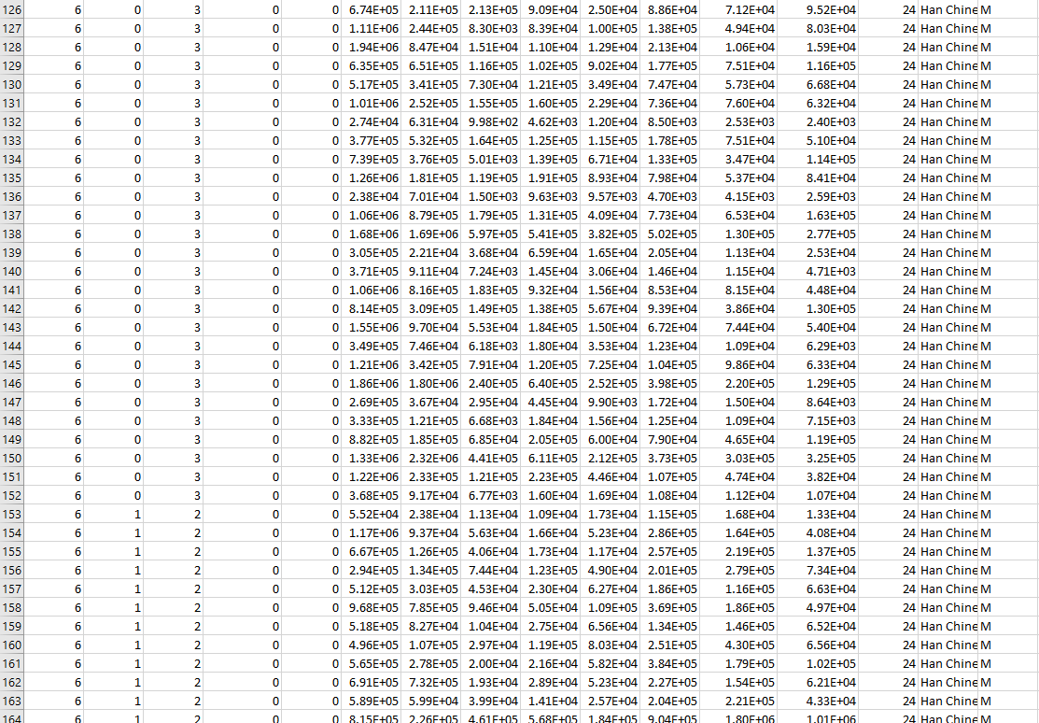

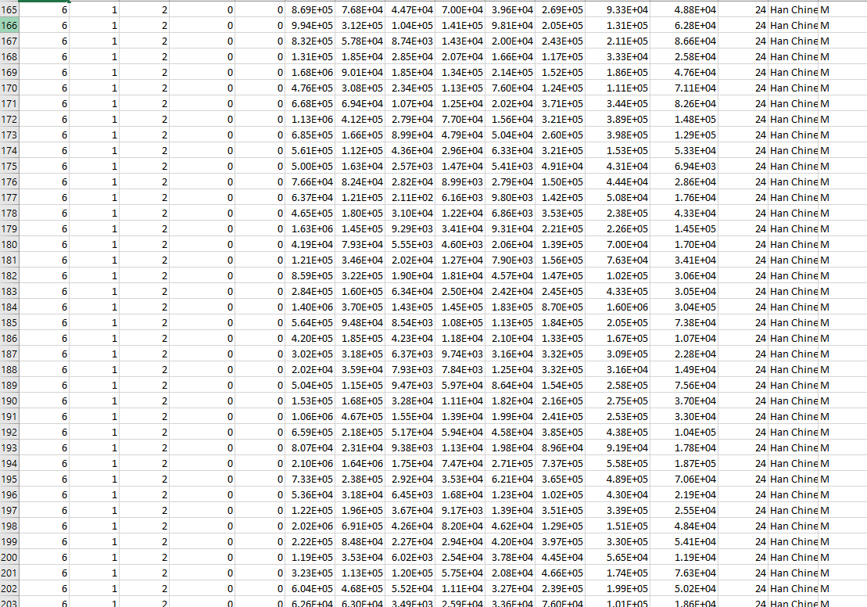

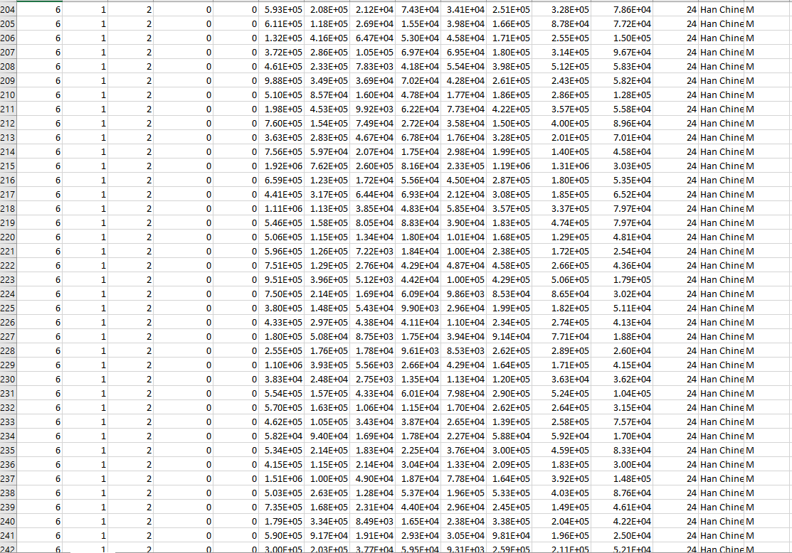

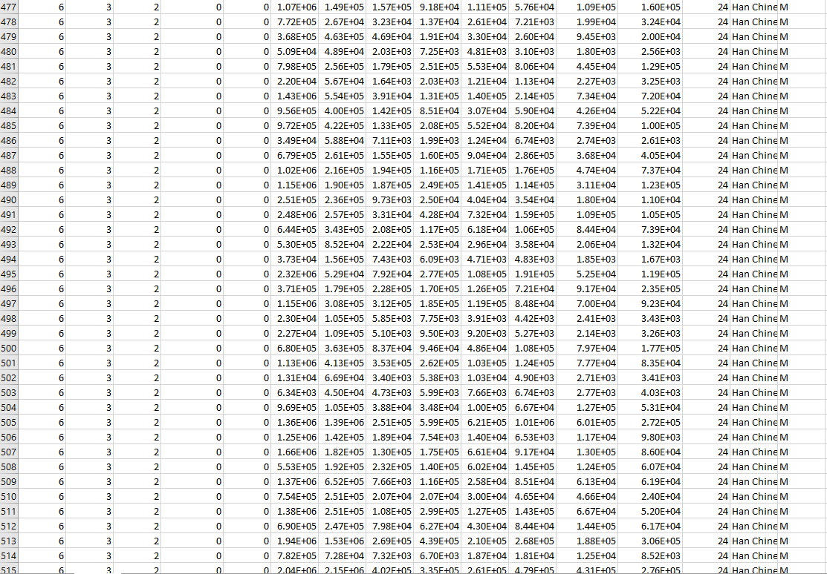

New Dataset from Kaggle